

Level 2

S1 Science Laboratory Skills –March

1. 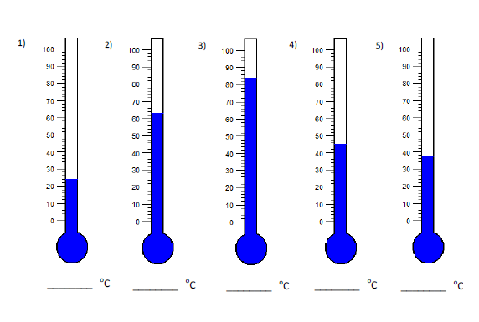**Read the temperature of each thermometer (0C)**
2. 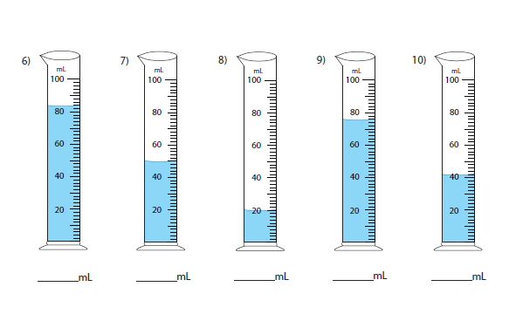**Measure the volume of millilitres in the measuring cylinder(ml)?**

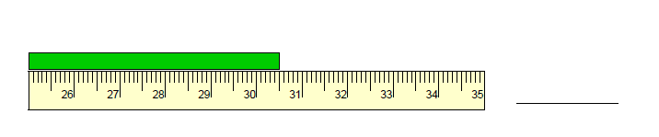**c) Measure the length of the bar (cm)**

11)

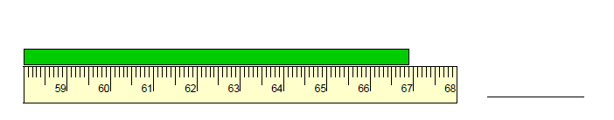

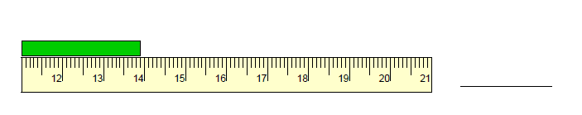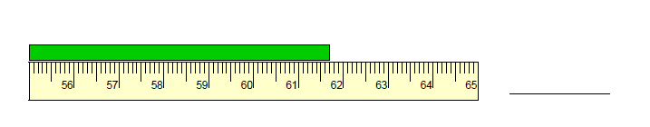12)

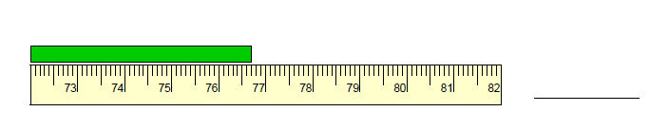

13)

14)

15)