****.

S1 Conversion Skills Homework –September

The metric system of measurement is used.

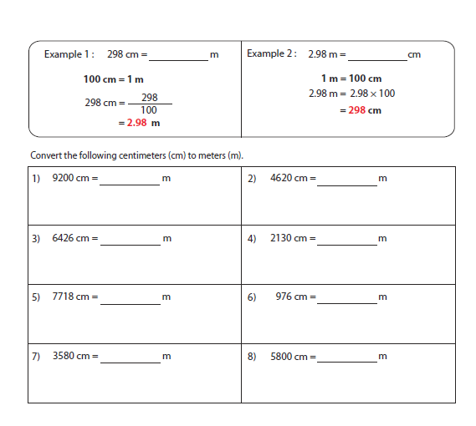To convert 1cm = 10mm 1m = 100cm 1km = 1000m

