

S1 Science Laboratory Skills - August

Level 2

1. 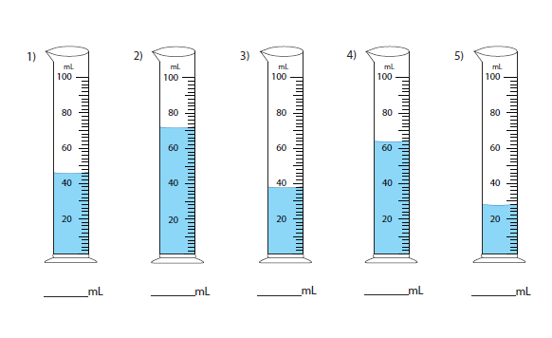**How many millilitres in the measuring cylinder?(ml**)
2. 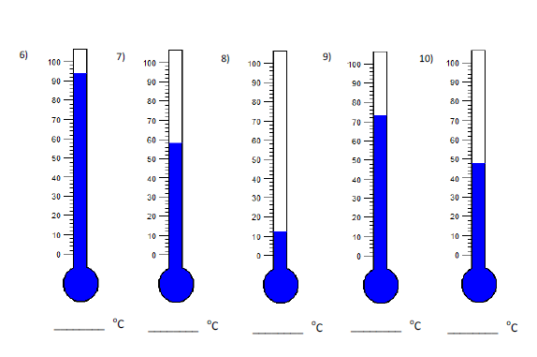**Read the temperature of each thermometer ( 0C)**

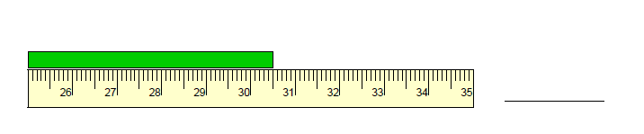**c) Measure the length of the bar (cm)**

11)

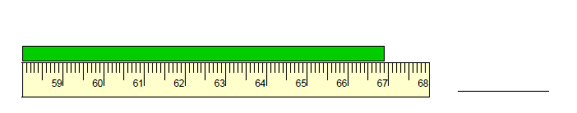

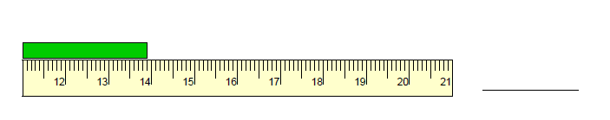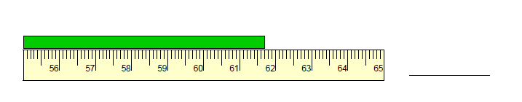12)

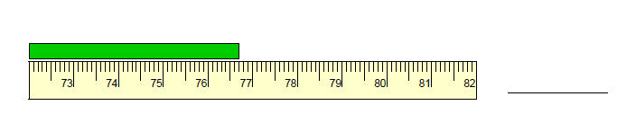

13)

14)

15)