Microbes and disease homework

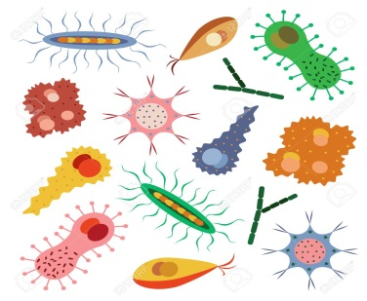

The answers to most of these questions should be in your

Science jotter. If not, you will need to research to find the

answers including the final question.

Level 3

1. Microbes are divided into three groups.

a) What are the three groups?

b) State one fact about each group.

2. Describe two safety precautions you should take when working

with microbes and state why.

3. Describe what you know about antibiotics.

4. Explain how a multidisc allows a doctor to prescribe the most

effective treatment for a bacterial infection.

5. Explain how the body defends itself against a disease with the

help of antibodies. (A diagram may help you to explain your answer)

6. Explain how vaccinations work.

7. Find out what Louis Pasteur is famous for. Provide at least three

pieces of information. State the source of your information and

why it should be trusted.