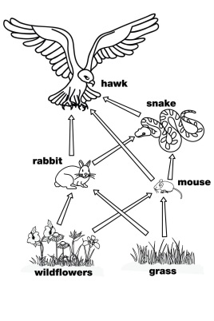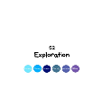Food chains and sampling homework

The answers to most of these questions should be in your

Science jotter. If not, you will need to research to find

the answers including the final question.

Level 2

1. Write out any food chain with at least three organisms.

2. For your food chain, state the producer and secondary consumer.

3. Why is a food web more stable than a food chain?

Level 3

4. Name the piece of equipment used to sample plants and describe

how it is used.

5. Why would a pitfall trap be set up in a particular habitat?

6. In carrying out any method of sampling, what should be done to

ensure answers obtained are reliable?

Level 4

7. Organisms need to be adapted to survive in their habitat.

Explain how this happens for a) polar bear and b) desert cactus.

8. Explain how biodiversity could be affected by -

a) population growth,

b) a named natural disaster.

9. Research one plant and one animal native to Scotland.

For each, state how they are adapted to live in their particular

habitat. State the source of your information and why it should

be trusted.