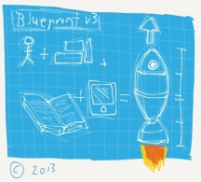 Building a rocket homework 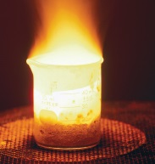

The answers to most of these questions should be in your Science jotter. If not, you will need to research to find the answers, including the final question.

Level 3

1. Items made of iron will rust if they are left outside. State **two** ways the iron can be protected from rusting.
2. Give an example of a metal that reacts quickly with water.
3. Metals are natural materials found in the earth. Why does gold exist in its pure form in the earth?

Level 4

1. Name the substances that cause the rusting of iron.
2. Potassium is only found in compounds and electricity is needed to extract it from its compound.

**Explain** what this indicates about the reactivity of potassium?

1. What is an alloy?
2. Select a metal from the electrochemical series, which when connected to iron, would protect the iron from rusting.
3. State the method of extraction would need to be used for copper to be extracted from its ore?
4. Iron is an important material used in a variety of buildings and products.

**Describe** how iron is extracted from its ore and **explain** the impacts that iron extraction has on the environment?