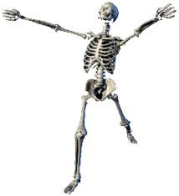

Multicellular Organisms.

National 4/5 Biology.

Bathgate Academy.

Name:



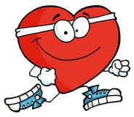

Producing New Cells

For an animal or plant to grow, their cells must divide. What other reason do cells need to divide?

Before the cell divides, the nucleus must divide. Why?

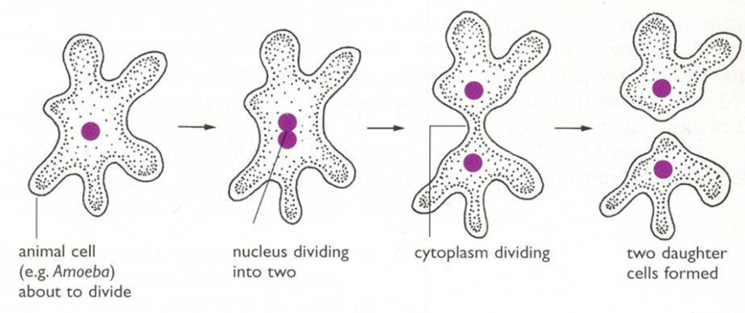

What can you say about the two daughter cells and the original parent cell?

The information in the nucleus is contained in structures called chromosomes. These are structures in which genetic information is packaged.

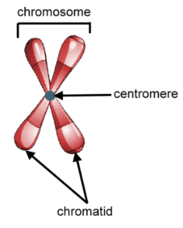

Add labels.

What is the difference between a chromosome and a chromatid?

The process of mitosis (division of the nucleus) followed division of the cytoplasm, ensures each new daughter cell has the same number of chromosomes as its parent cell (two matching sets).

What is important about the equator of the cell?

Why are the spindle fibres important?

Cancer arises when control over cell division is lost.

In humans, body cells contain 46 chromosomes which is known as the C_____________ C___________ (the diploid number)

Every organism has a specific chromosome complement. Cabbage = 18, hedgehog = 90, snail = 24. Find out about some others.

Genes and Inheritance

Genes are located on chromosomes in the nucleus. What are they are made of?

Genes determine our features and are inherited from our parents (half from our mother and half from our father).

*Sperm cell –*

Egg cell –

Zygote (fertilised egg) –

What is fertilisation?

The mixing of DNA from each parent creates variation. Variation can either be continuous or discrete.

Continuous variation:

Discrete variation:

Some characteristics are more dominant than others and this can be seen in a genetics cross. Biologists use these to make predictions about the chances of individuals inheriting certain characteristics.

Keywords for monohybrid crosses

Homozygous –

Heterozygous –

Gene –

Allele -

Dominant –

Recessive –

P1 -

F­1 –

F2 -

Phenotype -

Genotype -

Monohybrid crosses.

What is a monohybrid cross?

Example 1:

In retrievers, the golden colour is dominant to black. A homozygous golden retriever was crossed with a black retriever. Work out the predicted offspring in the F1 by carrying out a genetic cross.

Allocate letters for the characteristics: golden = black =

Parent phenotypes:

Parent genotypes:

Parent gametes:

F1 genotypes:

F1 phenotypes:

F1 phenotype ratio:

An individual from the F1 generation was crossed with a heterozygous individual. Carry out the monohybrid cross to the F2.

Try some other examples of monohybrid crosses in your jotter.

Monohybrid crosses give predictions of the phenotypes of offspring. Why are the predicted ratios not always achieved?

Many features are controlled by several genes. What it this type of inheritance called?

Give an example of this in humans.

Family trees can give information on the genotype and phenotype of individuals.

In humans, attached earlobes is recessive to unattached earlobes. The family tree shows the inheritance of attached earlobes through three generations. Those individuals with attached earlobes are shaded black.

B

**A**

**F**

**E**

**C**

**D**

**G**

Use the information in the family tree to give the genotypes and phenotypes of the following individuals:

A –

B –

G -

Sexual and Asexual reproduction in plants.

In order for a species to survive, individuals must pass on their genes to the next generation by reproducing. Reproduction can be sexual or asexual.

Asexual reproduction –

Sexual reproduction –

Sexual reproduction.

[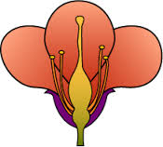](http://www.google.co.uk/imgres?imgurl=https://www.dlsweb.rmit.edu.au/toolbox/hort/tools/bookcase/botany/images/flower.gif&imgrefurl=https://www.dlsweb.rmit.edu.au/toolbox/hort/tools/bookcase/botany/flower_structure.html&h=198&w=219&tbnid=ojtSgB0mSDmkpM:&zoom=1&docid=UeF3HXPP_SGpEM&hl=en&ei=FQ5EVKq4K6uM7Ab9woGQDA&tbm=isch&ved=0CG0QMyg5MDk&iact=rc&uact=3&dur=479&page=4&start=51&ndsp=20)

The male gamete is and is produced in the .

The female gamete is and is produced in the .

Are gametes haploid or diploid?

What can be said about the offspring that result from sexual reproduction?

Seed formation and germination.

When the nuclei of a pollen grain and ovule meet (fertilisation) a seed may form.

In the right conditions, the seed will grow into a new plant.

What conditions do seeds need to grow and develop?

Why is sexual reproduction important to a species?

1.

2.

Asexual reproduction.

Asexual reproduction involves only parent and all the offspring produced are to that parent. It does not produce  but allows populations to grow quickly.

Humans can use plants’ ability to reproduce asexually in order to grow many plants. This is called plant propagation and there are different ways to do this:

1. Seeds (see above).
2. Cuttings
3. Bulbs
4. Tubers
5. Runners

Give five reasons why we grow plants.

Pharming.

Plants can be genetically modified to make medicinal (pharmaceutical) products. This is called pharming.

Give an example of a medicine that has been produced by pharming.

The need for transport.

Plants make their food by the process of . This occurs in the leaves. Photosynthesis requires water so plants must have a transport system that delivers water to the leaves.

Structure of xylem:

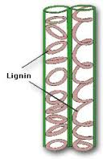

Why are xylem cells lignified?

As well as being needed for photosynthesis, water is also required to transport minerals that the plant may need.

Transpiration

Water must move in an upward direction in plants. The force that pulls water up is called the .

[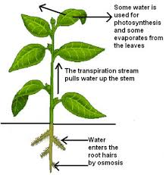](http://www.google.co.uk/imgres?imgurl=http://www.skinnerscience.com/Biology/gcse%20unit3%20revision%20notes_files/image023.jpg&imgrefurl=http://www.skinnerscience.com/Biology/gcse%20unit3%20revision%20notes.htm&h=419&w=397&tbnid=wsIsmJ3XLsxcQM:&zoom=1&docid=lWvvjU1oO1cN2M&hl=en&ei=4CBEVOm0JaHg7QaXqoDoBA&tbm=isch&ved=0CD8QMygXMBc&iact=rc&uact=3&dur=2192&page=2&start=15&ndsp=15)

What is transpiration?

When water evaporates from leaves, it moves through microscopic holes. What are these called?

[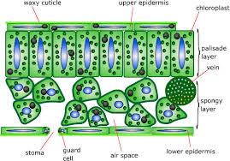](http://www.google.co.uk/url?sa=i&rct=j&q=&esrc=s&frm=1&source=images&cd=&cad=rja&uact=8&ved=0CAcQjRw&url=http://en.wikibooks.org/wiki/GCSE_Science/Plants&ei=LhZEVPH4Bdbmar2JgtAB&bvm=bv.77880786,d.ZGU&psig=AFQjCNHD05MCuZy35P0e5kAfSdJUOCke3w&ust=1413834644382354)A cross section of a leaf is shown in the diagram below:

What controls the opening and closing of the stomata?

Where are these cells found?

Which cells require water for photosynthesis?

Once in the leaves, the mesophyll cells may use the water for photosynthesis. As revision, summarise the two stages of photosynthesis below:

Once the sugar is made in the leaves it must be transported to the rest of the plant. What is the name of the tissue that does this?

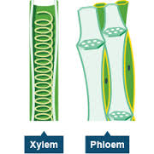

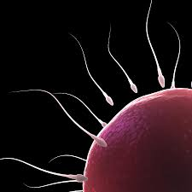Sexual reproduction in animals.

The male gamete is . It is produced in .

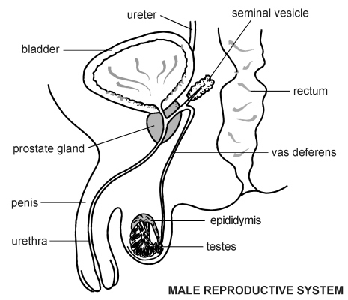

The female gamete is . It is produced in .

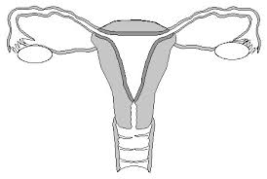

What is fertilisation?

What is the fertilised egg called?

Early embryo development:

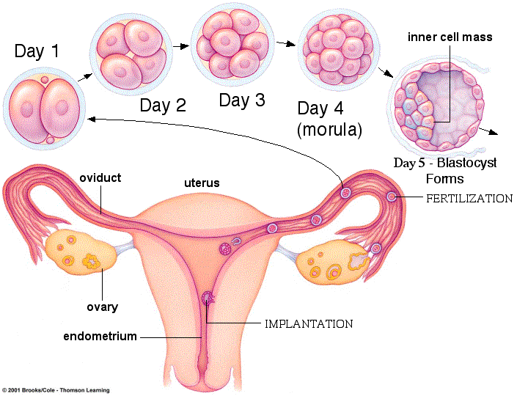

In both animals and plants the early cells in an embryo are unspecialised. What does this mean?

What are these early cells called?

By what process will these cells divide?

What do stem cells do?

Stem cells exist in animal adult tissues like bone marrow, muscle and brain. What is their function in adults?

Where are stem cells produced in plants?

What is the role of stem cells in plants?

As the number of cells in an organism increase, the stem cells start to specialise. This leads to the formation of a variety of tissues and organs.

Give examples of tissues in both animals and plants:

Give examples of organs in both animals and plants:

Groups of organs which work together form systems.

|  |  |
| --- | --- |
| Systems | Organs involved |
| Digestive |  |
| Nervous |  |
| Flower |  |

Biological organisation of animals and plants.

Cells

e.g.

Tissues – groups of cells that perform a particular function

e.g.

Organs – two or more tissues grouped together to perform a particular function

e.g.

Organ systems – groups of organs that carry out a particular function

e.g.

Control and communication.

In order for a multicellular organism to survive, it must be able to communicate internally. What does this mean?

1. Nervous control.

The nervous system consists of the central nervous system (CNS) and nerves. The CNS consists of the brain and spinal cord.

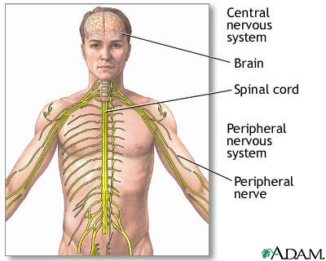

The brain.

[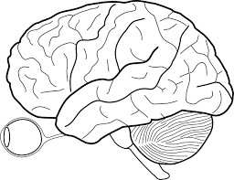](http://www.google.co.uk/url?sa=i&rct=j&q=&esrc=s&frm=1&source=images&cd=&cad=rja&uact=8&ved=0CAcQjRw&url=http://www.rudyard.org/blank-brain-diagram/blank-brain-diagram/&ei=pdVfVIeYBMmN7Aao2YCYCw&psig=AFQjCNHXk0iAUrfckoR6ea6GyWmAyrf4qg&ust=1415653142473780)

|  |  |
| --- | --- |
| Part | Function |
| Cerebrum |  |
| Cerebellum |  |
| Medulla |  |

Nerve cells (neurons).

Neurons carry electrical messages from one part of the body to another. There are three types of neurones:

Sensory Inter Motor

Receptors detect a sensory input or stimulus and the sensory neuron passes the message to the CNS. Give an example of a sensory stimulus:

Once a sensory neuron has been stimulated, a message is sent along the neuron as an *electrical* impulse.

The place where two neurons meet is called a ________. What happens here?

Neuron 1.

Neuron 2.

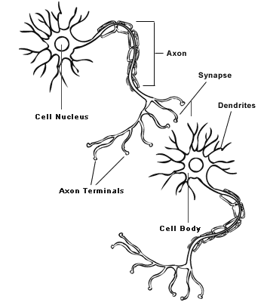

Once the CNS has processed the information from the sensory neuron, it makes the appropriate response. Responses can be:

1. Rapid in action – e.g.
2. Slower in response – e.g.

The structure and function of a reflex arc.

Some actions of the body take place automatically and are called reflexes.

The reflex arc:

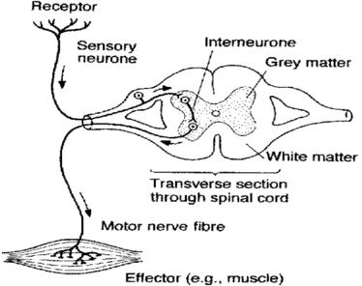

Use different colours to show where the different types of neurons are in the reflex arc.

Give two examples of a reflex in the table below:

|  |  |  |
| --- | --- | --- |
| Stimulus detected by sensory neuron. | Desired response. | Why is this a reflex? |
|  |  |  |
|  |  |  |

Hormonal control.

What are hormones?

Where are hormones released from?

List some of the major endocrine glands in humans.

Hormones are often produced far away from the tissues which they affect. How do they only cause an effect on some tissues?

Blood glucose regulation.

Blood glucose levels are controlled by hormones.

Raised glucose level (through eating) detected by cells in the .

Reduced glucose level (through exercise) detected by cells in the .

Normal blood glucose level

(set point).

Regulating the level of blood glucose so that it remains relatively constant is called homeostasis.

Regulation of body temperature.

1.

2.

3.

Normal temperature

(set point).

Increased temperature (due to exercise)

1.

2.

Reduced temperature

Temperature is another example of control by homeostasis.

Animal transport and exchange systems: gases.

Oxygen and carbon dioxide are transported around the body by the .

Blood contains a mixture of cells. Name some of the cells that are found in blood.

Red Blood Cells

How are red blood cells specialised to transporting oxygen?

When oxygen is present it combines with haemoglobin to make oxyhaemoglobin.

+

Oxyhaemoglobin transports oxygen to body cells as the red blood cells travel within the circulatory system.

White blood cells

These are part of the immune system and are involved in destroying pathogens.

What are pathogens?

There are two main types of cells involved.

1. Phagocytes which carry out phagocytosis by engulfing pathogens.

Draw a diagram to explain how phagocytosis involves engulfing and digestion.

2. Some lymphocytes produce antibodies which destroy pathogens.

Each antibody is specific to a particular pathogen.

Draw a diagram to illustrate this specificity.

Structure of the heart:

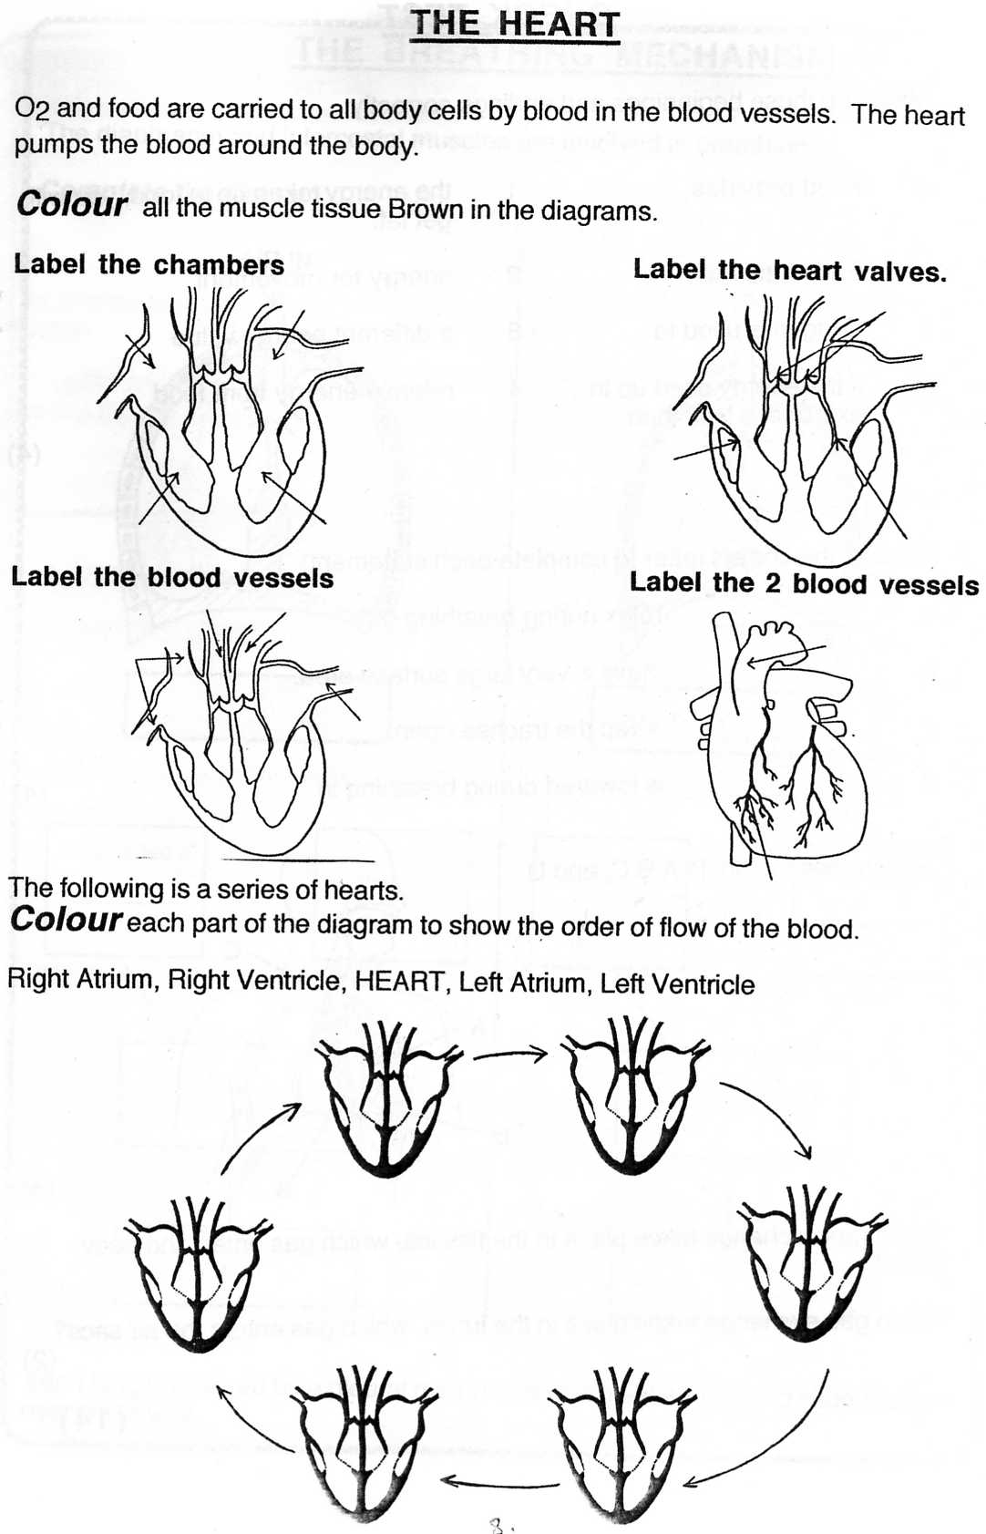

Where are valves located in the heart?

What is the function of the valves?

Movement of blood through the heart and associated blood vessels:

Lungs

Body cells

The coronary arteries.

The heart itself is made of many muscle cells. Why do these require oxygen?

[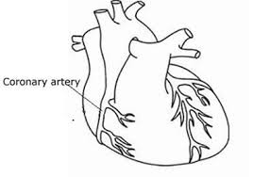](http://www.google.co.uk/imgres?imgurl=http://www.cuh.org.uk/resources/images/add/services/clinical/cardiology/cardiac_rehab/heart_and_coronary_arteries.jpg&imgrefurl=http://www.cuh.org.uk/addenbrookes/services/clinical/cardiology/cardiac_event/cardiac_events_index.html&h=274&w=390&tbnid=Wm4URzR_Ns1NmM:&zoom=1&docid=89fZXUdHGw93wM&hl=en&ei=uAyGVLaXBK-y7QbxxIHQBQ&tbm=isch&ved=0CH8QMyhDMEM&iact=rc&uact=3&dur=468&page=4&start=57&ndsp=23)

What is the function of the coronary arteries?

What will happen if the coronary artery becomes blocked?

What could cause a coronary artery to become blocked?

Blood vessels.

There are three types of blood vessels:

1. Arteries
2. Capillaries
3. Veins e.g.

[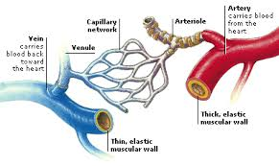](http://www.google.co.uk/imgres?imgurl=http://www.factmonster.com/images/ESCI353BLOVES003.gif&imgrefurl=http://www.factmonster.com/dk/science/encyclopedia/circulatory-system.html&h=239&w=400&tbnid=rFdzNEZfJ5W_qM:&zoom=1&docid=ViSmP6YeVUICRM&hl=en&ei=fw6GVPGrK83V7Ab8qYHwCg&tbm=isch&ved=0CGYQMyg2MDY&iact=rc&uact=3&dur=624&page=4&start=53&ndsp=22)

Nutrients are transported around the body by the.

Animal transport and exchange systems: gases.

[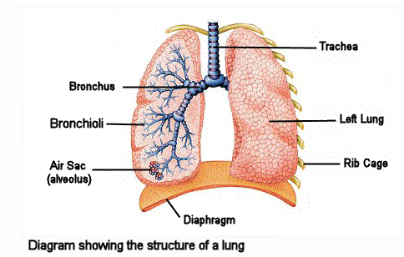](http://www.google.co.uk/url?sa=i&rct=j&q=&esrc=s&frm=1&source=images&cd=&cad=rja&uact=8&ved=0CAcQjRw&url=http://www.mikecurtis.org.uk/ks2_respiratory_system.htm&ei=u-qqVOWpB-qt7gb2woHgDg&bvm=bv.82001339,d.ZGU&psig=AFQjCNEDhgBZdjlIcYqvdNOvZ9b9Tzr7Pw&ust=1420573731055085)

Describe the passage of air through the lungs:

Nose

What keeps the trachea and bronchi open?

The lungs are lined with mucus and tiny hairs called cilia.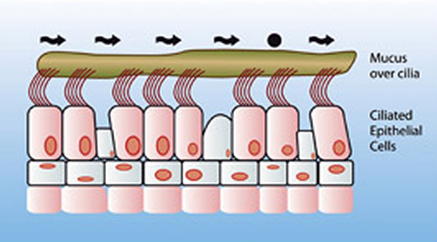

Why is there mucus in the lungs?

What do the cilia do?

Close up of an alveolus (air sac):

[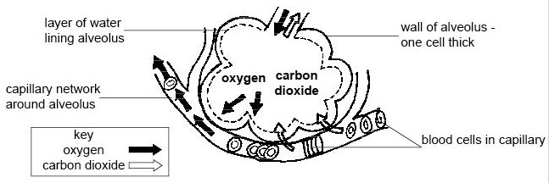](http://www.google.co.uk/url?sa=i&rct=j&q=&esrc=s&frm=1&source=images&cd=&cad=rja&uact=8&ved=0CAcQjRw&url=http://en.wikibooks.org/wiki/Anatomy_and_Physiology_of_Animals/Respiratory_System&ei=Z_uqVLC4O-S57gbCgoHYDg&bvm=bv.82001339,d.ZGU&psig=AFQjCNGBOw6jk930SEnXchV46IiRuQP6Ig&ust=1420577837699163)

What are exchanged through the alveolar walls?

What transports these gases around the body?

Name three features of alveoli that make them efficient structures for gases to diffuse:

1.

2.

3.

The Digestive System

What is the role of the digestive system?

[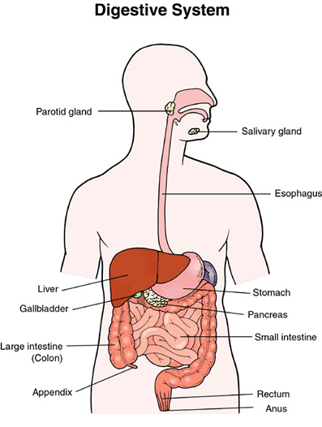](http://www.google.co.uk/url?sa=i&rct=j&q=&esrc=s&frm=1&source=images&cd=&cad=rja&uact=8&ved=0CAcQjRw&url=http://www.2beingwell.com/human-digestive-system/&ei=MQCrVMqZPIr2UMTUgqgL&bvm=bv.82001339,d.d24&psig=AFQjCNFq6ddmhXLiXwDw66mBR5F4jvKEkA&ust=1420579216058875)

Food is moved through the digestive system by a process called peristalsis.

Describe the process of peristalsis using the diagram below:

[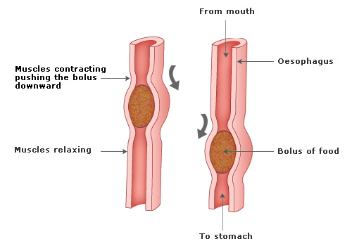](http://www.google.co.uk/url?sa=i&rct=j&q=&esrc=s&frm=1&source=images&cd=&cad=rja&uact=8&ved=0CAcQjRw&url=http://www.passmyexams.co.uk/GCSE/biology/digestive-system.html&ei=fAKrVKOiONHU7Aaa4oHoDg&bvm=bv.82001339,d.ZGU&psig=AFQjCNEzZAglil8uobKkRkk3FFRlwHkXZw&ust=1420579798820502)

Absorption of nutrients.

The small intestine is where the small, soluble products of digestion are absorbed. Complete the table to show what these are:

|  |  |
| --- | --- |
| Food group | Small, soluble products of digestion |
| Carbohydrate |  |
| Protein |  |
| Fat |  |

The small intestine contains many tiny structures called villi which absorb the products of digestion. Label the diagram of a villus below and show where each product is absorbed.

[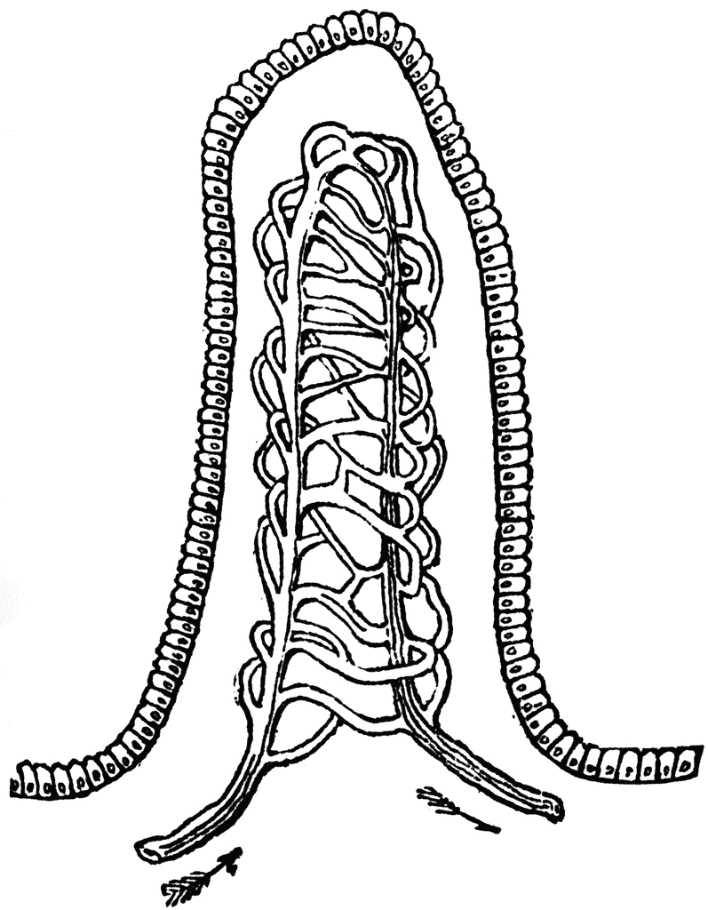](http://www.google.co.uk/url?sa=i&rct=j&q=&esrc=s&frm=1&source=images&cd=&cad=rja&uact=8&ved=0CAcQjRw&url=http://etc.usf.edu/clipart/22200/22287/villus_22287.htm&ei=WgarVPrLGsWr7AaF04DYDg&bvm=bv.82001339,d.ZGU&psig=AFQjCNH2apRLg0YCi4hpsuzrqihsm-bPxg&ust=1420580801172276)

How are the villi suited to their function?

1.

2.

3.

To remain healthy, humans have certain requirements. Make a note of them under the headings-

A balanced diet

Water

Minerals

Vitamins

Suitable conditions