Bathgate Academy

National 4/5 Biology

[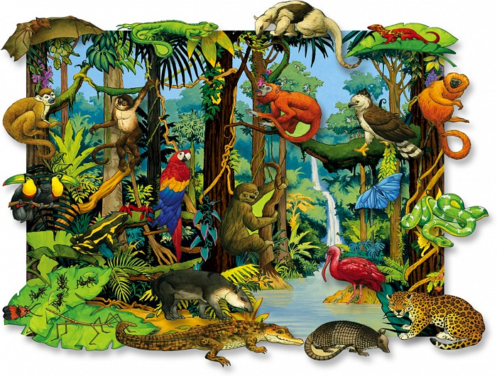](http://www.asd20.org/Schools/rres/Teachers/Michele_Davis/PublishingImages/Forms/DispForm.aspx?ID=1)

Life on Earth

Name:

1. Ecosystems

An ecosystem consists of all the living organisms (the community) living in a particular habitat and the non- living components with which the organisms interact.

There are a number of ecological terms that are required in this unit.

Species –

Biodiversity –

Population –

Producer –

Consumer –

Herbivore –

Carnivore –

Omnivore –

Predator –

Prey –

Food chain –

Food web -

All living things need energy. Animals and plants depend on each other for a number of things including food, shelter and pollination.

A food chain shows the flow of energy through a series of organisms.

Grass Rabbit Fox

From the food chain, what is the –

Producer -

Primary consumer -

Secondary consumer –

Why could the primary consumer be described as a herbivore?

Why could the secondary consumer be described as a carnivore?

What is an omnivore?

Food webs show the interaction of food chains. They are delicately balanced as the removal/addition of one species will impact those remaining.

FOX EAGLE

LAMB RABBIT

GRASS SEEDLINGS

If all the rabbits died,

What might happen to the number of seedlings?

Explain why?

What might happen to the number of lambs?

Explain why?

What might happen to the number of foxes?

Explain why?

What would be the possible impacts on all the species in the food web if farmers were given money to farm more sheep on their land?

Write a short paragraph in your jotter to describe your thoughts.

Predators and prey

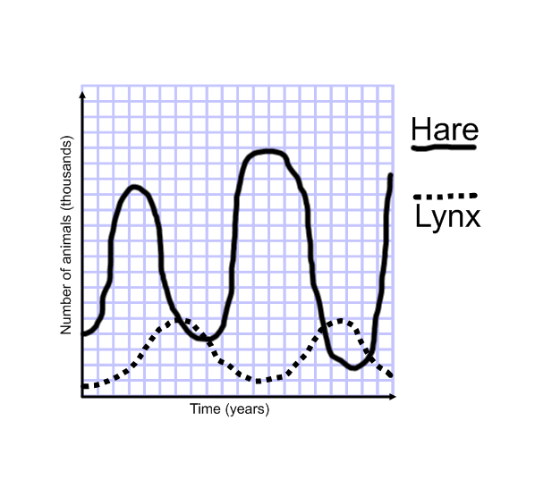The graph shows the relationship in population numbers of the snowshoe hare and the lynx.

Predator =

Prey =

What is the main reason for the decrease in population of the hare?

What is the main reason for the decrease in population of the lynx?

A niche is the role that an organism plays within the community. It relates to the resources it requires in its ecosystem.

These include - Light

Nutrient availability

Interactions with other organisms in the community

Competition

Predation

Ability to tolerate conditions such as temperature.

Competition in ecosystems

Competition in ecosystems occurs when resources are in short supply.

Interspecific competition

This occurs amongst individuals of species for one or a few of the resources they require.

Interspecific competition in squirrels

Describe the niche of the red squirrel (native to UK) and the grey squirrel (introduced to UK). Use the words competition, parasites, disease, and predation in your description.

Use the diagrams below to write about the effects of competition that has occurred between these two species.

Red squirrel distribution Grey squirrel distribution

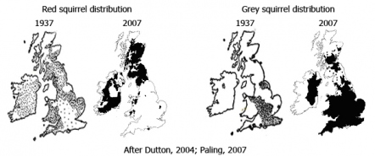

1937 2007 1937 2007

Intraspecific competition

This occurs amongst individuals of the species and is for all resources required.

What would members of the same plant species compete for?

What would members of the same animal species compete for?

Which form of competition is more intense (interspecific or intraspecific)?

Why?

Investigate intraspecific competition in germinating cress seeds.

2. Distribution of organisms

Biotic and abiotic factors affect biodiversity.

These factors can increase or decrease biodiversity in an ecosystem.

Biotic factors are directly related to living organisms.

These include 1

2

3

4

5

Abiotic factors are non-living factors that affect the distribution of organisms.

These include 1

2

3

4

Measuring abiotic factors

|  |  |  |  |
| --- | --- | --- | --- |
| Factor | Apparatus | Source of error | How to minimise error |
| Soil Moisture |  |  |  |
| Light intensity |  |  |  |
| Temperature |  |  |  |
| pH |  |  |  |

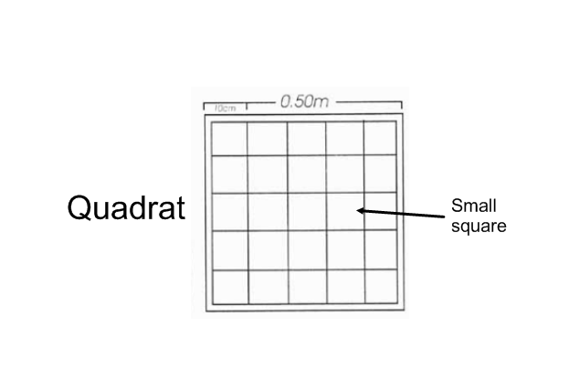Sampling biotic factors

Quadrats are used to estimate the number of plants of a particular type in an area.

What is the area of this quadrat?

Describe how to use a quadrat -

Several samples should be taken and an average calculated. Why?

What can you do if some plants are not completely inside the quadrat?

Sampling small invertebrates

Describe, with the aid of a diagram, how you would set a pitfall trap.

When sampling with pitfall traps there are a number of possible errors that need to be considered and dealt with.

|  |  |
| --- | --- |
| Possible error | Solution |
| Animals are unable to fall into trap |  |
| Trap becomes flooded |  |
| Birds are eating contents of trap |  |
| Some animals in the traps get eaten by others |  |

How do you ensure that you have obtained a representative sample when using pitfall traps?

If you set up pitfall traps, observe any organisms that you have caught.

Can you identify anything?

To help identify animals and plants we often use identification keys.

Below is a paired statement key.

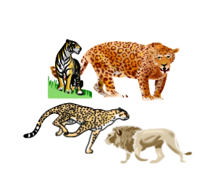

1. Stripes.....................................TIGER

No stripes...................Go to (instruction) 2

2. Spots..........................................Go to 3

No spots....................................LION

3. Spots completely black .........CHEETAH

Spots not completely black....JAGUAR

Practice making and using paired statement keys.

The effects of biotic factors

Yeast are single celled fungi that reproduce by mitosis.

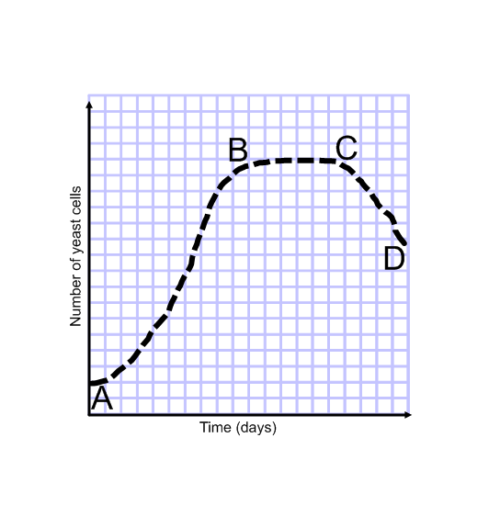The graph below shows what happens to a population of yeast cells over time.

Describe and explain the change in population of yeast cells for each of the following stages;

A – B;

B – C;

C – D;

Competition occurs when resources are in short supply.

Effects of grazing on biodiversity

Many plant species are consumed by animals. This is known as grazing.

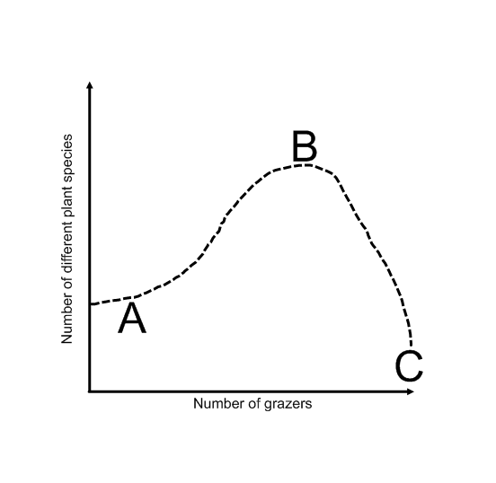

Explain why the number of different plant species is LOW at;

Point A –

Point C –

Why is the number of different plant species HIGHER at point B?

Indicator Species

Indicator species are species that by their presence or absence indicate environmental quality/levels of pollution.

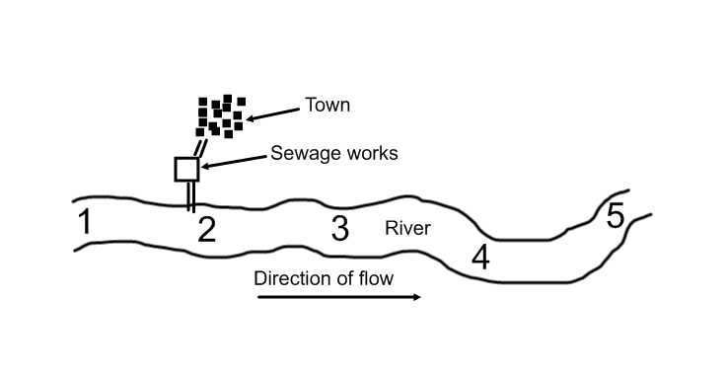Freshwater invertebrates are used as indicators to assess quality.

Make notes in the space below.

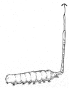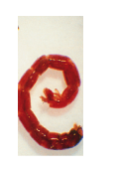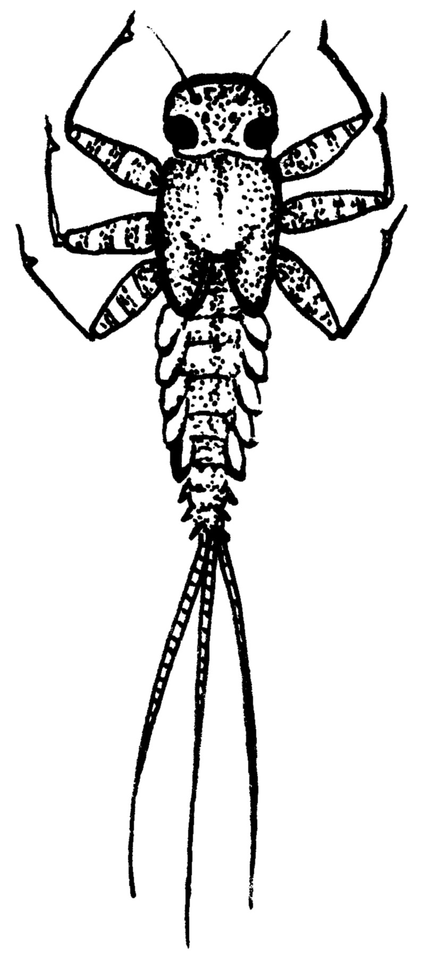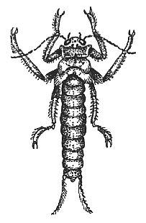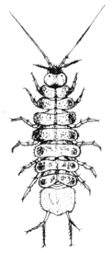

Lichens are simple plants that can be used as indicators of quality.

Make notes in the space below -

3. Photosynthesis

This is a two stage process which occurs in the chloroplast and is controlled by enzymes.

Stage 1 Light Reactions

Light energy from the sun is trapped by chlorophyll in the chloroplasts and converted into chemical energy in the form of ATP.

sun

chlorophyll traps light energy

water hydrogen acceptor

energy

ADP + Pi ATP

Complete the diagram to show what water splits into. What happens to the oxygen?

Stage 2 Carbon Fixation

Hydrogen and ATP from the light reaction is used with carbon dioxide to produce sugar.

Show this as a diagram.

All reactions in each stage are controlled by ____________.

The chemical energy in the sugar produced has three fates –

1

2

3

Limiting Factors

These are factors which, if in short supply, will limit the process of photosynthesis. Explain why each will have an impact on photosynthesis and cell growth.

1 Carbon Dioxide Concentration

2 Light Intensity

3 Temperature

4 Water

By overcoming these limitations, faster growth rates can be achieved.

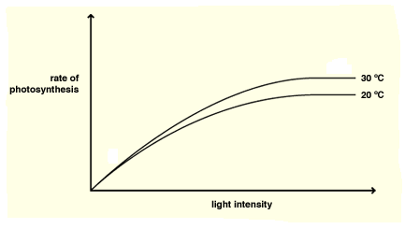Limiting Factor Graphs

When the graph is rising, the limiting factor is the factor on the x-axis. (In this example, light intensity)

When the graph levels off, it is one of the other factors. (in this example, temperature)

Write out a summary word equation for photosynthesis.

4. Energy in ecosystems

Energy transfers from one level to the next in a food chain. The majority of this energy is lost as -

1.

2.

3.

Only a very small quantity is used for growth and is therefore available at the next level in a food chain.

Information about food chains can be represented in the form of pyramids.

A pyramid of numbers is A pyramid of energy is

a diagram that shows the a diagram that shows the

total number of organisms energy available at each

at each link in a food chain. link in a food chain.

1 fox 120 units

100 rabbits 1,200 units

1 million grass plants 12,000 units

For each of the food chains below, use the information to draw a pyramid of numbers and a pyramid of energy in your jotter.

1. Oak tree Greenfly Ladybirds

|  |  |  |  |
| --- | --- | --- | --- |
| Numbers | 1 | 8,500 | 10 |
| Energy (KJ/m2/year) | 100,000 | 10,000 | 1,000 |

2. Grass Rabbits Fleas

|  |  |  |  |
| --- | --- | --- | --- |
| Numbers | 1,000,000 | 50 | 1000 |
| Energy (KJ/m2/year) | 1,300 | 130 | 13 |

3. Plant plankton Animal plankton Blue Whale

|  |  |  |  |
| --- | --- | --- | --- |
| Numbers | 5,000,000 | 6,000,000 | 1 |
| Energy (KJ/m2/year) | 900,000 | 90,000 | 9,000 |

What type of pyramid is the most reliable?

Explain why?

5. Food Production

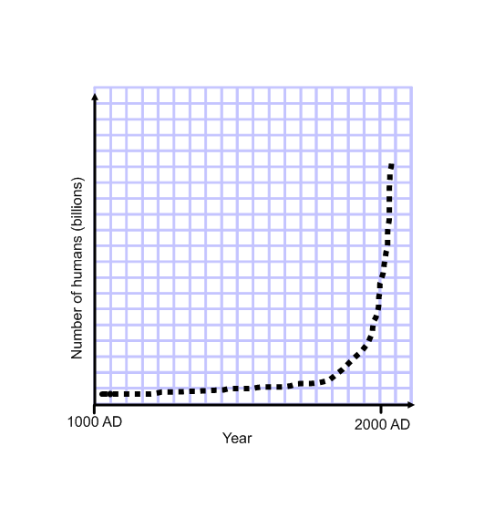

The human population has ‘exploded’ in recent times.

What factors may have caused this to happen?

This increase in human population requires increased food yield from farming operations. Describe the benefits and limitations of;

Genetically modified (GM) crops -

In addition, the use of fertilisers and pesticides can be involved to meet the increased demand for food.

Fertilisers – These provide chemicals such as nitrates which increase crop yield.

Pesticides – These kill plants and animals which reduce crop yield.

Nitrogen in ecosystems

All living things need a source of nitrogen to make protein for growth.

The nitrogen is recycled through a set of processes known as the nitrogen cycle.

Bacteria and fungi are vital to this cycle as they decompose dead animals and plants to release the nitrogen back into the soil.

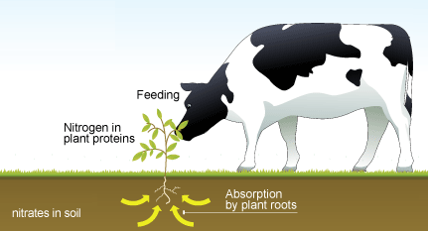

2

1

3

1. Nitrates dissolved in soil water are absorbed into plants via their roots.

2. Nitrates are used to produce amino acids which are synthesised into plant proteins.

3. Animals consume plants or other animals to obtain amino acids for protein synthesis.

Fertilisers

When crops are harvested, nitrogen is taken out of the cycle so needs to be replaced.

Nitrogen can be added to the soil in the form of nitrate fertilisers, manure or compost.

Describe the benefits and limitations of each fertiliser.

|  |  |  |  |
| --- | --- | --- | --- |
|  | Nitrate fertiliser | Manure | Compost |
| Benefits |  |  |  |
| Limitations |  |  |  |

Creation of an algal bloom

* Fertilisers containing nitrogen can leach from soil into fresh water, adding extra, unwanted nitrates.
* This will increase algal populations which can cause algal blooms.
* Algal blooms reduce light levels killing aquatic plants.
* These dead plants, as well as dead algae, become food for bacteria which greatly increase in number.
* The bacteria use up large quantities of oxygen, reducing oxygen availability for other organisms.

With the aid of labelled diagrams show the development and effects of an algal bloom.

Genetically modified (GM) crops can be grown to reduce the use of fertilisers.

Explain how genetically modified rice plants do this.

Pesticides

With intensive farming methods being used to increase crop yield, pesticide use is increasing. However, pesticides sprayed onto crops can remain in the environment for a long time and accumulate in the bodies of organisms (bioaccumulation).

As they are passed along food chains, toxicity increases and can reach lethal levels e.g.,

Algae Waterfleas Fish Osprey

0.0001 ppm toxin 0.01 ppm 0.2 ppm 2.0 ppm

(Reach a lethal level

at end of food chain)

Using DDT as an example, describe the negative effects of pesticide use.

Biological control may be an alternative to the use of pesticides.

Describe the use of ladybirds as a biological control species.

Genetically modified (GM) crops can be grown as an alternative to the use of pesticides.

Explain how genetically modified cotton plants do this.

Impact of environmental disruptions on biodiversity

Human population growth has resulted in habitat destruction deforestation

over fishing climate change

intensive agriculture genetic pollution

oil/chemical spills acid rain

sewage litter

Research each of these environmental disruptions and make notes on three.

1.

2.

3.

These environmental disruptions have had a negative impact on biodiversity.

The impact of natural hazards on biodiversity

On March 2011, an earthquake followed by a tsunami hit Japan killing an estimated 16,000 people. Other natural hazards such as forest fires, floods and volcanic activity also reduce biodiversity. Research all five of these hazards and make notes on three.

1.

2.

3.

These natural hazards will also ____________ biodiversity

6. Evolution of species

Adaptations for survival

Plants and animals must adapt in order to survive and reproduce in their environment.

An adaptation makes an organism more suited to its environment.

They do this in a variety of ways;

1. Physiological adaptation - Body/tissue functions, e.g., sweating;

2. Structural adaptation – Body design, e.g., flight feathers;

3. Behavioural adaptation (animals only) – act in a way to boost survival, e.g., hibernation.

Complete the table below with examples of adaptations of the named organisms.

|  |  |  |  |
| --- | --- | --- | --- |
| Organism | Physiological adaptations | Structural  adaptations | Behavioural adaptations |
| Kangaroo rat |  |  |  |
| Polar bear |  |  |  |
| Desert  Cactus |  |  |  |
| Great white shark |  |  |  |

Behavioural adaptations

Behaviour is important for a species to survive.

Behaviour can be innate (pre-programmed) e.g., a grass snake playing dead when threatened.

Behaviour can be learned e.g., urban foxes living near humans.

Changes in behaviour due to internal and external stimuli are of benefit to survival.

Innate behaviour

Describe and explain the purpose of the ‘waggle dance’ performed by bees.

Experiment – Choice chamber responses of woodlice.

Learned behaviour

Describe short-term, temporary avoidance and habituation behaviour in snails.

Experiment – Design a finger maze and test pupils when blindfolded.

Evolution of adaptations

Adaptations are changes that occur in response to changes in the environment.

They are inherited characteristics that make an organism best adapted to survival in its environment.

What is a mutation?

Mutations are spontaneous and are the only source of new alleles.

Mutations may neutral, confer an advantage or a disadvantage to survival.

Find examples that fit the following categories;

Neutral mutation –

Advantageous mutation –

Disadvantageous mutation –

Some environmental factors act as ‘mutagenic agents’ that can increase mutation rates. List some mutagenic agents below.

The new alleles produced by mutation allow plants and animals to adapt to their environment.

Variation

Variation within a population makes it possible for a population to evolve over time in response to changing environmental conditions. Natural selection is key to making this happen.

What is a species?

Who coined the phrase ‘natural selection’?

Describe what is meant by the term natural selection?

What phrase did Herbert Spencer use to describe natural selection?

Natural selection in action

The peppered moth

Speciation - the formation of new species

Speciation occurs after part of a population becomes isolated by an isolation barrier.

Barriers are - 1. Geographical

2. Ecological

3. Reproductive

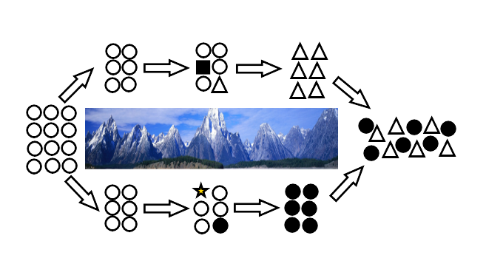

Study the diagram below.

Add numbers to the correct stage of the diagram.

1. Single population of one species.

2. Isolating barrier separates population into two sub-populations.

3. Different mutations occur in each sub-population, some of which are an advantage.

4. Natural selection selects for different mutations in each group due to different selection

pressures.

5. Each sub-population evolves until they become so genetically different that they are two

different species.

6. Isolating barrier removed and the two sub-populations are able to join up again.

Sub-populations are no longer able to interbreed to produce fertile offspring.

Speciation has occurred.

Research how the following examples show evidence of speciation;

1. Darwin’s finches

2. Lemurs on Madagascar

3. Evolution of the pentadactyl limb