1. Cell Structure

Cells are the building blocks of all life. Discuss what you remember about cells.

Label the diagrams and complete the table.

Animal Cell Plant Cell

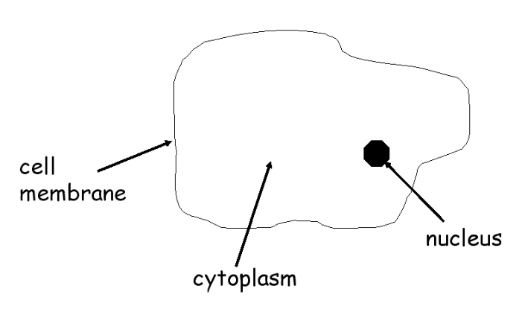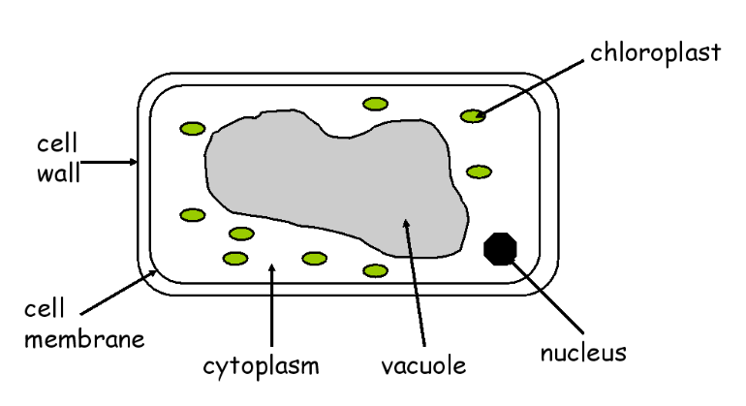

|  |  |
| --- | --- |
| Structure | Function |
| Nucleus |  |
| Cytoplasm |  |
| Membrane |  |
| Chloroplast |  |
| Cell wall |  |
| Vacuole |  |

Use microscopes and bioviewers to look at some animal and plant cells. In your jotter, draw what you view adding labels to all structures. Write the magnification of each specimen.

Organelles

Organelles are the name given to the structures found inside the cell. You already know about six of them but you also need to know about mitochondria and ribosomes.

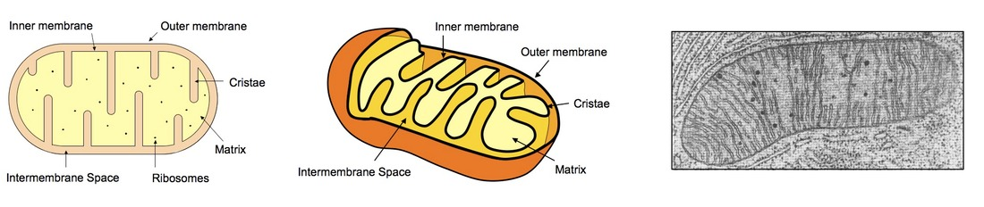

In what part of the cell are mitochondria found?

What do they do?

In what part of the cell are ribosomes found?

What do they do?

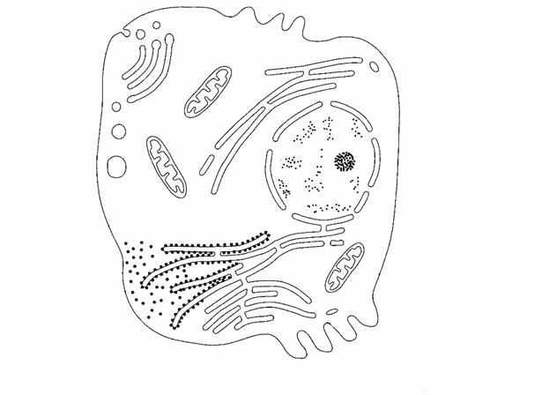

Label all parts of the animal cell.

Label all parts of the plant cell.

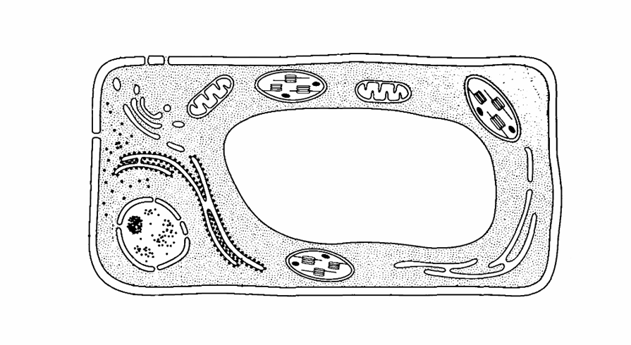

What makes this a plant cell?

Bacterial Cells eg. *E.coli*

Bacteria are single celled organisms found everywhere. They are found on and in the human body, in the air we breathe, on the surfaces we touch, in the food we eat.

Most bacteria are helpful. Uses include -

A small number of bacteria are harmful. Why?

Label the typical bacterial cell.

Bacteria do not have a true nucleus. What do they have instead?

They also have a smaller ring of genetic material called a plasmid. Add this to your diagram. What does the plasmid do?

Bacteria do not have mitochondria, so where does respiration (energy production) take place?

Fungal Cells eg. yeast

Fungal cells are decomposers. They get their energy by breaking down dead or decaying material as their food source. As they do this, they release nutrients into the soil.

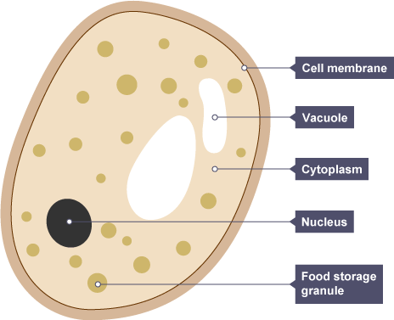

cell membrane vacuole cytoplasm nucleus

cell wall

Fungi are similar to plant cells but they do not have any __________________.

What process can they not carry out?

Summary of cell structures –

|  |  |  |  |  |
| --- | --- | --- | --- | --- |
| Structure present? | Animal Cell | Plant Cell | Bacterial Cell | Fungal Cell |
| Cell wall |  |  |  |  |
| Cell membrane |  |  |  |  |
| Cytoplasm |  |  |  |  |
| Nucleus |  |  |  |  |
| Vacuole |  |  |  |  |
| Chloroplasts |  |  |  |  |
| Ribosomes |  |  |  |  |
| Mitochondria |  |  |  |  |
| Plasmid |  |  |  |  |

Cell walls are found in plant, bacterial and fungal cells. However, the structure of the cell wall is different in each.

Plant cell walls are made of cellulose. Fungal and bacterial cell walls are not.

Properties of Micro-organisms and their Use in Industry

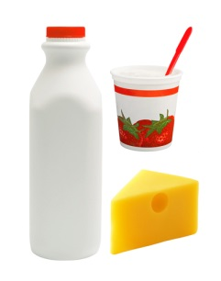Micro-organisms grow rapidly and can use a variety of food sources, so they are very useful in making a wide range of products.

Uses of Bacteria

1 Production of Yoghurt and Cheese

To make yoghurt, bacteria feed on lactose sugar present in milk.

What product do they make which gives yoghurt its taste?

Write an equation to show this.

Write about cheese production.

2 Sewage Treatment

Bacteria are used to breakdown sewage into harmless products. What gas do the bacteria require to carry out this process?

3 Production of Biogas (methane)

Bacteria can feed on organic waste and produce biogas which is an alternative fuel.

What is organic waste?

What use can be made of biogas?

Why is it important that alternative fuels are produced?

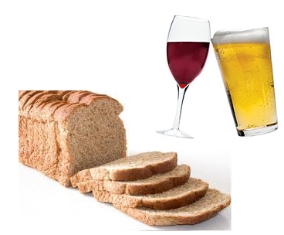

Uses of Yeast

1 Brewing (production of beer and wine)

Yeast feeds on sugar to make alcohol and carbon dioxide. The reaction is called fermentation. Show this as an equation.

What is the useful product in brewing?

2 Baking (bread making)

The same process of fermentation occurs in bread making. The useful product is the carbon dioxide. Why?

What happens to the carbon dioxide and yeast?

Carbon dioxide -

Yeast -

3 Production of Gasohol

This is another alternative fuel. Yeast ferments the sugar from sugar cane and the product is mixed with petrol to make gasohol. Show this as an equation.

Notice any similarities?

2. Transport across the cell membranes

The cell membrane is composed of a double layer of phospholipids with proteins scattered throughout.

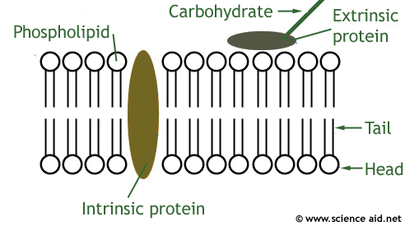

The membrane is described as a fluid mosaic model. Why?

The membrane is selectively permeable only allowing small molecules to pass through. Give some examples –

The proteins create channels to slightly larger molecules such as glucose and amino acids allowing their passage across the membrane.

Other molecules are too large to pass through. Give an example –

Diffusion is the movement of molecules down a concentration gradient from an area of ________ concentration to an area of ______ concentration.

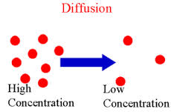

It is a passive process. What does this mean?

The difference in concentration between two regions is called a ____________ _______.

It is important that substances such as oxygen, glucose and carbon dioxide can move in and out of cells by diffusion. Different concentrations of these substances will exist depending on their environment.

Osmosis is the movement of water molecules from a higher water concentration to a

lower water concentration through a selectively permeable membrane.

Energy is not required. What type of process is it?

The movement of water by osmosis is important in animal cells. Draw the appearance of an animal cell immersed in different water concentrations -

0.8% salt

pure water 0.8%salt 2% salt

Water conc. outside the Water conc. outside the Water conc. inside the cell is higher than cell is the same as inside cell is higher than outside inside so water so there is no net so water moves out by moves in by osmosis. movement of water. moves out by osmosis.

Cell __________ Cell ___________ Cell ____________

Osmosis affects plant cells differently. Draw diagrams to show the effects.

Water conc. outside the Water conc. outside the Water conc. inside the cell is higher than cell is the same as cell is higher than outside inside then water inside there is no net then water moves out by moves in by osmosis. movement of water. moves out by osmosis.

Cell becomes ________ Cell is ____________ Cell becomes _________

Active transport

The protein molecules in the cell membrane can move molecules and ions _____________ a concentration gradient.

This requires energy so is described as an _________ process.

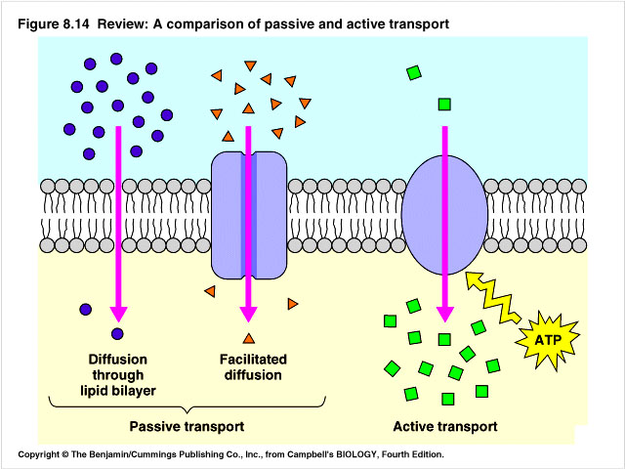

______ concentration

protein in membrane

high concentration

3. DNA and production of proteins

[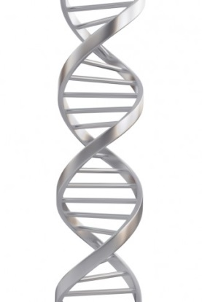](http://quoteko.com/id7/dna-strand-picture.html)Genes are located on chromosomes in the nucleus. They are made of DNA which carries the genetic information to make proteins.

DNA is composed of two strands which coil to form a double helix.

Each strand is composed of sub-units called nucleotides.

Label -

There are four different bases. What are their names?

What are the complementary base pairings?

What type of bond links them together?

Why is the sequence of bases important?

DNA is only located in the nucleus. Messenger RNA (mRNA) is a molecule which carries a complementary copy of the genetic code from the DNA, in the nucleus, to a ribosome.

Describe what then happens at the ribosome?

What makes each individuals DNA unique?

DNA bases m RNA bases Amino acids Protein

4. Proteins

Proteins have a variety of shapes and functions. What determines what the function will be?

Complete the table.

|  |  |
| --- | --- |
| Function | Example |
| Enzyme |  |
| Hormone |  |
| Antibody |  |
| Structural |  |
| Receptors |  |

The enzymes made by all living cells are called biological catalysts. What are the two important properties of enzymes?

1.

2.

The substrate is the substance the enzyme works on and must fit the shape of the enzyme exactly. This ensures the products are produced as a result. The shape of the active site of an enzyme molecule is complementary to its specific substrate.

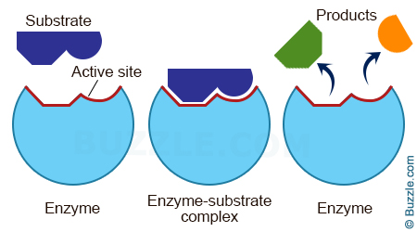

In your jotter, draw some examples to illustrate the complementary shapes of active sites and their substrates.

Enzymes can be involved in degradation reactions (break down). Give an example below.

Enzymes can be involved in synthesis reactions (build up). Give an example below.

Enzymes are used widely in industry. eg the manufacture of baby foods, the production of biological washing powders, sports drink industry and the production of ice cream. Research an industry and explain clearly why enzymes are important.

Optimum Conditions for Enzymes

Each enzyme has a set of conditions at which it works best. This is known as its ___________ conditions.

Enzymes and other proteins can be affected by temperature and pH.

Enzymes in the human body have an optimum temperature of 37oC. Why?

Many enzymes have an optimum pH that is neutral.

Name an enzyme that works best in acidic conditions.

When the temperature gets too high or the pH is too extreme, the shape of the enzyme is changed which affects the rate of reaction. What term describes this?

Draw the effect this would have on the active site.

5. Genetic Engineering

Genetic information can be transferred from one cell to another naturally or by genetic engineering.

DNA can be inserted into bacterial plasmids or viruses. They will then make something that they did not make before. Below are the stages involved in making a bacterial cell make the human hormone insulin.

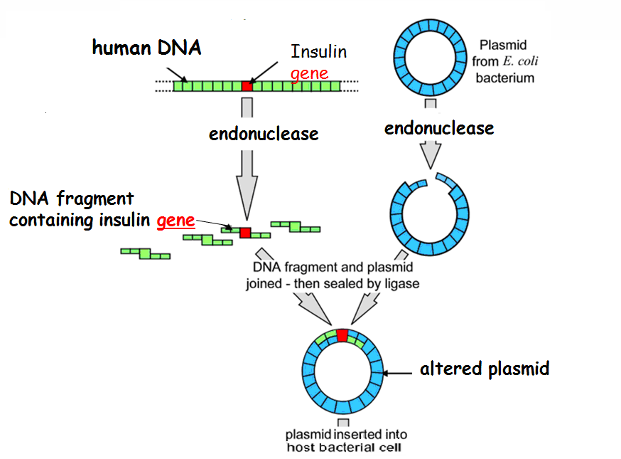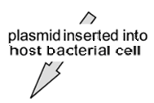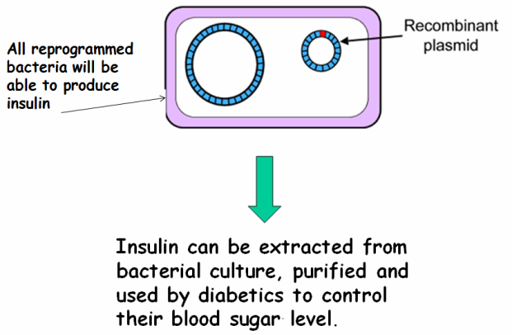

The insulin gene is identified. Plasmid is removed from a bacterial cell.

In addition to insulin, what else can be produced using genetic engineering?

Enzymes are essential in the process of genetic engineering.

Genetically Modified Organisms

What is meant by the term GM organism?

Strawberries have a gene inserted that produces an antifreeze chemical. What is the advantage of this?

Tomatoes have a gene inserted that stops an enzyme for ripening being made. What is the advantage of this?

Enzymes are important in the production of genetically modified organisms.

Therapeutic use of cells

Stem cells are cells that can divide and produce more cells or become specialised. They are involved in the natural growth and repair of our bodies throughout life. In addition, they can also be used to treat and help cure diseases related to the pancreas, liver, lungs, brain, heart, eyes, skin and bone marrow.

Where are stem cells found in the body?

Pick an organ in the body and find out about the diseases that may affect it and how stem cells can be used to treat them.

6. Respiration

This is the release of the chemical energy stored in glucose. It occurs in all cells, through a series of reactions which are controlled by ____________.

Write out the equation for respiration -

The energy released from the breakdown of glucose is used to generate ATP.

The energy transferred by ATP can be used for many processes in cells such as -

1

2

3

4

The process of respiration begins in the cytoplasm.

Glucose is broken down to two molecules of pyruvate and two molecules of ATP.

Glucose 2 Pyruvate + 2ATP molecules

If oxygen is present, aerobic respiration takes place. This occurs in the mitochondria. Each pyruvate is broken down to carbon dioxide and water. This releases enough energy to yield a large number of ATP molecules.

Pyruvate carbon dioxide + water + large number of ATP molecules

Aerobic respiration

In the presence of oxygen, yeast, plant and animal cells use glucose to produce carbon dioxide, water and ATP. Write this as an equation.

Fermentation in animal, plant and yeast cells

In the absence of oxygen, fermentation occurs.

Animal cells

The pyruvate molecules are converted to lactate. Write this as an equation.

Plant and yeast cells

The pyruvate molecules are converted to carbon dioxide and ethanol. Write this as an equation.

The breakdown of each glucose molecule via the fermentation pathway yields only the initial two molecules of ATP.

Controversial Biological Procedures

There are a number of controversial topics in biology that cause a great deal of debate. These include gene therapy, pharming and transgenic animals.

You will research one of these to present to the class.