**[](http://www.google.co.uk/imgres?imgurl=http://workoutenginepro.workoutengine.com/static/workoutenginepro/2011/09/idea.jpg&imgrefurl=http://www.missanisah.com/2012/11/eureka-moments.html&h=331&w=143&tbnid=tAgAuKofwsjdZM:&zoom=1&docid=RHJehdMD1lQeoM&ei=EJdaVMIM8JCxBLLTgpAF&tbm=isch&ved=0CD4QMygXMBc&iact=rc&uact=3&dur=444&page=1&start=0&ndsp=33)S2 skills homework – October – Percentages**

If I get stuck I can ask my teacher for help!

1. To Calculate a percentage first work out the fraction
2. Then multiply the fraction by 100

**OR**

1. To calculate a figure from a percentage write the percentage as a fraction of 100
2. Then multiply this fraction by the total number

Write down the following as a percentage

1. 24 out of 48
2. 6 out of 24
3. 5 out of 40
4. 10 out of 1000
5. 19 out of 20

Calculate the following values

1. 20% of 40
2. 1% of 150
3. 15% of 300
4. 25% of 4
5. 50% of 36
6. The table below contains the nutritional information for a can of beans. Copy and complete the table with the missing percentage weights

|  |  |  |
| --- | --- | --- |
|  | Mass in food (g) | Percentage Mass |
| Carbohydrate | 37.5 |  |
| Fat | 15 |  |
| Protein | 7.5 |  |
| Water | 90 |  |
| TOTAL | 150 |  |

1. A chemistry pupil is studying the reaction between marble chips and Hydrochloric. Each of the chips has a mass of 65g before the starting the experiment.

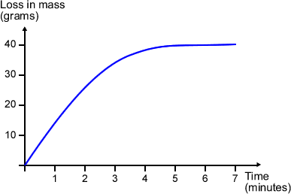

1. How long did it take for the reaction to stop?
2. What was the mass of the chip after 2 minutes?
3. What percentage of the chip was remaining after the reaction had finished?
4. The waste from a local food processing factory is shown in the table below.

Copy and complete the table with the missing values of mass

|  |  |  |
| --- | --- | --- |
|  | Mass in waste (kg) | Percentage Mass |
| Potato peelings |  | 2 |
| Fruit pulp |  | 5 |
| Milk whey |  | 25 |
| Paper |  | 45 |
| Sewage |  | 18 |
| Micro – organisms |  | 5 |
| TOTAL | 500 |  |

1. 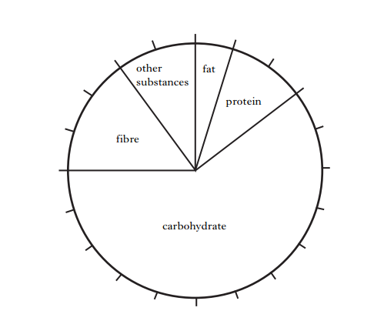Oatmeal and Wheatmeal are two cereal products. The pie chart below gives information about compounds found in **Oatmeal**

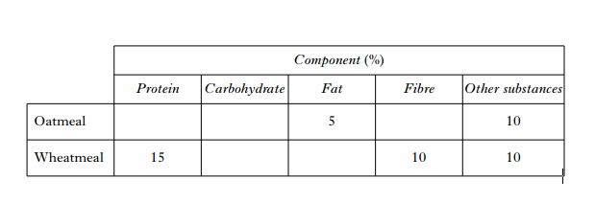 **Wheatmeal** contains **less fibre** and **more protein** than **oatmeal**. The proportions of all the other components are the **same**.

1. Use all the information provided to copy and complete the following table.
2. Calculate the mass of **protein** present in an 80g portion of **Wheatmeal**