S2 - Numeracy Homework August - Averages

1. Calculate the average of the following sets of numbers
2. 3, 17, 4, 12
3. 1005, 1007, 1005, 1018, 1010
4. 3.6, 4.9, 5.4, 5.3, 4.8, 2.9, 3.3, 4.8
5. 17.34, 17.28, 17.39, 17.31, 17.33
6. 2.78, 2.04, 2.67, 3.01, 2.98, 3.6
7. Christine, Hazel and Gary are growing 5 samples of plant seedlings for an experiment. The number of plant shoots per sample was recorded in the table shown below

|  |  |  |  |  |  |
| --- | --- | --- | --- | --- | --- |
|  | Number of plant shoots in a sample | | | | |
| Christine | 4 | 3 | 5 | 0 | 5 |
| Hazel | 5 | 7 | 8 | 7 | 6 |
| Gary | 0 | 1 | 7 | 5 | 6 |

1. Calculate the average number of plant shoots in Christine’s experiment
2. Calculate the average number of plant shoots in Hazel’s experiment
3. Calculate the average number of plant shoots in Gary’s experiment
4. Gary is overheard saying “ Christine and myself have a higher combined average than Hazel” Show by calculation if he is correct.
5. Calculate the average number of plant shoots across all three experiments
6. A class of pupils are investigating the relationship between Bee’s and flowers in a small flower bed. Over the course of a week they recorded how many Bee’s visited each type of flower. Their results are recorded in the table shown below

|  |  |  |  |  |  |  |  |
| --- | --- | --- | --- | --- | --- | --- | --- |
| Flower type | Number of bee’s per day | | | | | | |
| Roses | 4 | 6 | 4 | 7 | 2 | 5 | 5 |
| Violets | 3 | 12 | 1 | 2 | 3 | 1 | 1 |
| Daffodils | 6 | 5 | 7 | 5 | 8 | 4 | 6 |
| Lilac Bush | 10 | 11 | 9 | 8 | 11 | 12 | 10 |
| Moonflower | 7 | 7 | 8 | 7 | 5 | 8 | 6 |

1. Calculate the average number of Bee’s that visited **each** plant over the course of the week.
2. Which plant had the greatest average bee population?
3. Some of the pupils think one of their results is inaccurate. Which one do you think is inaccurate **and** why do you think this?
4. The Height of three cress plants is measured on 4 separate days as part of a class experiment. Their results are recorded each time and shown in the table below.

|  |  |  |  |  |  |
| --- | --- | --- | --- | --- | --- |
|  | Starting height (cm) | Height – day 1  (cm) | Height – Day 2  (cm) | Height – day 3  (cm) | Height – day 4  (cm) |
| 1st cress plant | 2.7 | 2.8 | 3.1 | 3.3 | 3.8 |
| 2nd cress plant | 1.9 | 2.2 | 2.4 | 2.9 | 3.3 |
| 3rd cress plant | 3.0 | 3.0 | 3.2 | 3.6 | 3.8 |

1. Calculate the average **growth** per day for **each** of the plants.
2. The cress plants are allowed to grow until day 6. Use your averages from a. to predict the height of each plant after 6 days.

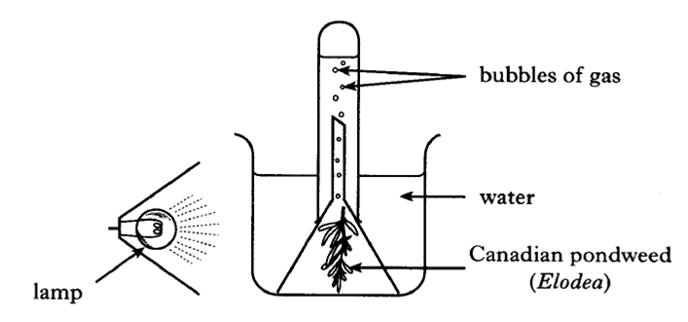5.

A group of 5 pupils measure the volume of oxygen produced during the photosynthesis of pondweed. They take repeat readings so that an average volume of oxygen can be calculated. Their results are shown below

|  |  |  |  |
| --- | --- | --- | --- |
|  | Volume of oxygen produced (cm3) | | |
|  | 1st attempt | 2nd attempt | 3rd attempt |
| Group 1 | 0.62 | 0.64 | 0.59 |
| Group 2 | 0.46 | 0.46 | 0.39 |
| Group 3 | 0.55 | 0.60 | 0.59 |
| Group 4 | 0.81 | 0.78 | 0.75 |
| Group 5 | 0.33 | 0.45 | 0.45 |

Calculate the average volume of oxygen produced for **each** group.