**National 5 revision questions (Unit 2)**

**Alkanes, Alkenes, Cycloalkanes and Reactions**

1a. Write the meaning of the term ‘homologous series’

1b. Name the alkanes that contain

(a) 1 carbon atom and (b) 4 carbon atoms.

2 . (a) Write the general formula for the alkanes.

(b) Give the molecular formula for each of the following

(i) butane (ii)methane (iii) octane

(c) Draw the full structural formula for the above compounds.

1. Write the shortened structural formula for

(a) C2H6

(b) C4H10

1. Write the general formula for the cycloalkanes.
2. Draw the (i) full structural formula (ii) molecular formula for

(a) cyclopropane

(b) cyclopentane

6. Write the general formula for the alkenes.

7. Name the alkene with the number of C atoms stated (a) 3 (b) 5 (c) 6

8. Draw the (i) full structural formula (ii) molecular formula for

(a) propene

(b) butene

9. Write the molecular formula for

1. the sixth member of the alkane series.
2. The cycloalkane with 5 carbon atoms.
3. The fourth member of the alkene series
4. An alkene with a total of 27atoms.

10. (a) Explain the meaning of the term “isomer”.

(b) Draw two isomers of C4H10

(c) Draw two isomers of C3H6 , one of which is **saturated** and the other unsaturated.

(d) Explain the meaning of the term “saturated” and “unsaturated.”

11. C4H8 could be two different types of hydrocarbon. Name the homologous series of hydrocarbons they could belong to and draw two possible structures

12. One of the first anaesthetics to be used was chloroform (CHCl3). The table below shows the anaesthetic effect of methane and some chlorine compounds (like chloroform) which was based on methane.

|  |  |
| --- | --- |
| **Compound** | **Anaesthetic effect** |
| CH4  CH3Cl  CH2Cl2  CHCl3 | None  Weak  Moderate  Strong |

(a) Using the information in the table, what general statement can be made about the compounds and their anesthetic effect?

(b) Methane can be made to react with chlorine gas to give chloroform and hydrogen chloride. Use symbols and formulae to write an equation for this reaction.

13. Class 3H, were studying hydrocarbons. Here are some statements from the pupils’ notes.

|  |  |
| --- | --- |
| A | It has no isomers |
| B | It has the general formula CnH2n |
| C | It contains only single carbon to carbon bonds. |
| D | It is a hydrocarbon |

(a) Which statement can be applied to **both** butane and cyclobutane? (2 boxes)

1. which statement can be applied to propane **but not** to butane (1 box)

14. Draw the extended structural formula for

(a) Propene (b) cyclopropane

(c) butane (d) ethene

* 1. Write the names for the following hydrocarbons

(a) CH3 CH2 CH= CH CH2 CH3 (b) CH3 CH2 CH2 CH= CH2

16. Write the molecular formula for the following hydrocarbons.

  

(a) (b) (c)

17. Each box in the grid below shows the name or the formula of a compound

|  |  |  |
| --- | --- | --- |
| A | B  butane | C  cyclopentane |
| D  ethene | E | F  cyclopropane |

Identify the box(es) which show

(a) an alkene (2 boxes) (b) an alkane ( 2 boxes) (c) an isomer of box E

18.

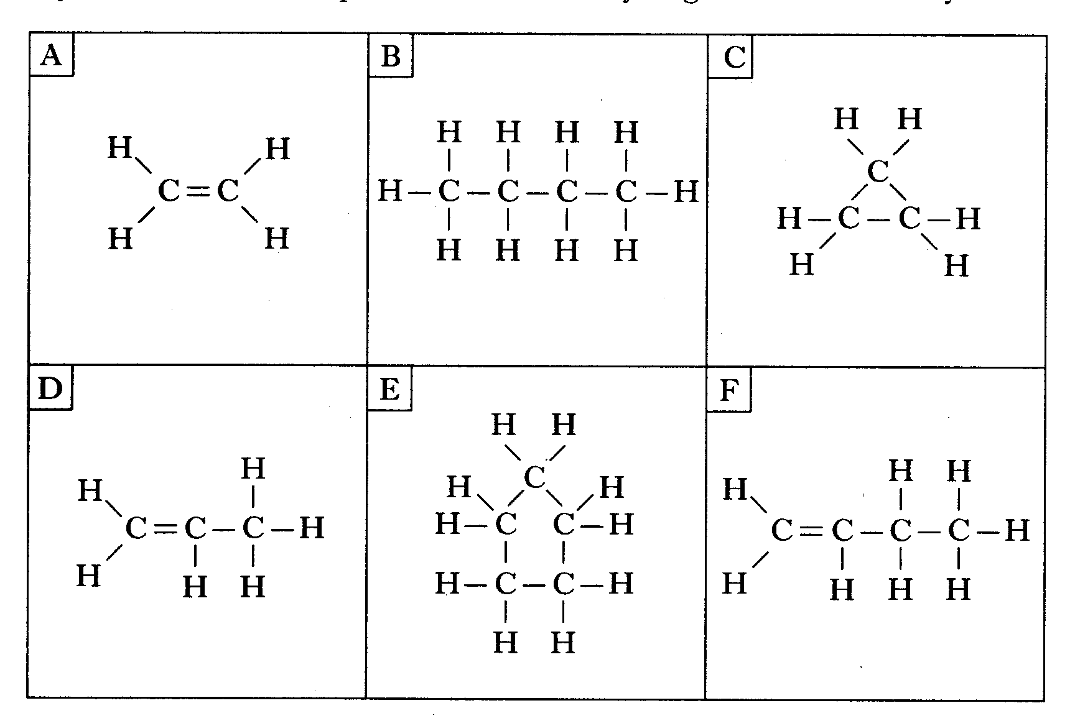

(a) Identify the hydrocarbon which reacts with hydrogen to form butane.

(b) Identify the 2 isomers.

(c) Identify the hydrocarbon(s) which is (are) the first member(s) of a homologous series.

19.

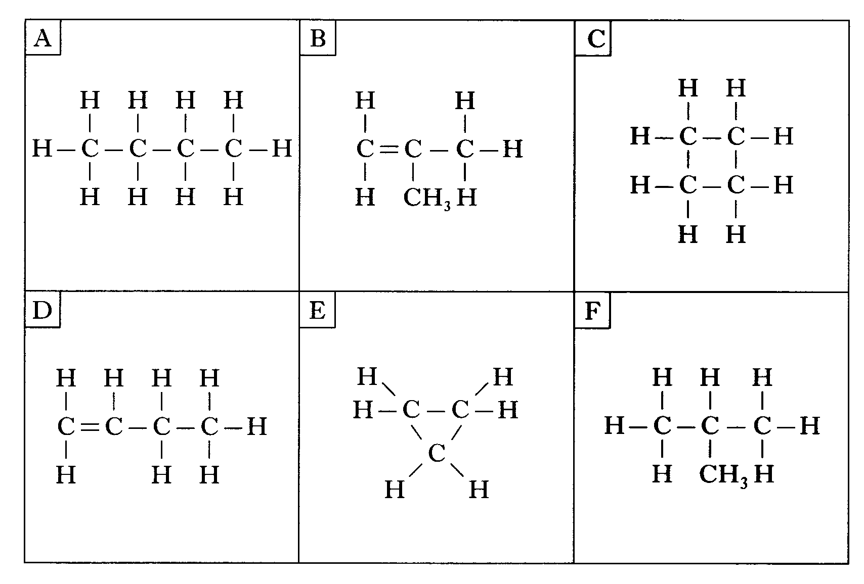

(a) Identify the 2 hydrocarbons which would quickly decolourise bromine solution.

(b) Identify the isomer of the hydrocarbon in box D which belongs to a different homologous series.

**Alcohols, Carboxylic Acids, Esters and Reactions**

20. (a) Draw full structural formula for the following compounds:

(i) propan-1-ol

(ii) 2,2-dimethylhexane

(iii) ethanol

(iv) butanoic acid

(v) propanoic acid

21. Give the systematic name for the following hydrocarbons:

B



A



22. Which of the following compounds is **not** an isomer of heptane?

(a) 2,3-dimethylbutane (b) 2,3-dimethylpentane

(c) 2,2-dimethylpentane (d) 2-methylhexane

23. Name the following compounds

A



B



C

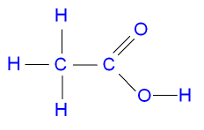

24. Describe a use for the following:

(a) alcohol

(b) carboxylic acid

(c) ester

**Calculations: Enthalpy**

1. In one experiment the burning of ethanol, resulted in the temperature of 400cm3 of water rising from 14.2oC to 31.6oC.

Use the information to calculate the energy released during the reaction.

2.

A student dissolved ammonium chloride in 200cm3 of water and found that the temperature of the solution fell from 23.2oC to 19.8oC.

Calculate the enthalpy change for the reaction.

3.

Methanol, CH3OH, is burned and the heat energy given out increased the temperature of 100g of water from 22oC to 32oC.

Calculate the enthalpy change.

4.

Ammonium nitrate, NH4NO3, is dissolved in 200cm3 of water. The temperature of the water falls from 20oC to 17.1oC.

Calculate the enthalpy change for this reaction.

5.

When KCl is dissolved in water the enthalpy change is + 16.75kJ mol-1.

What will be the temperature change when 14.9g of potassium chloride is dissolved in 150cm3 of water?