**National 4 revision questions (Unit 2)**

1. Natural gas is a good fuel. Complete combustion of the fuel results in an **exothermic** reaction producing carbon dioxide and water.
2. What elements must be present in natural gas?
3. What gas in the air is required for complete combustion?
4. Give the definition of the term ‘fuel’
5. A liquid X is made of only **2 elements**. It burns to produce 2 products. One is a colourless liquid which freezes at 0 oC and boils at 100 oC; the second turns limewater a milky colour.

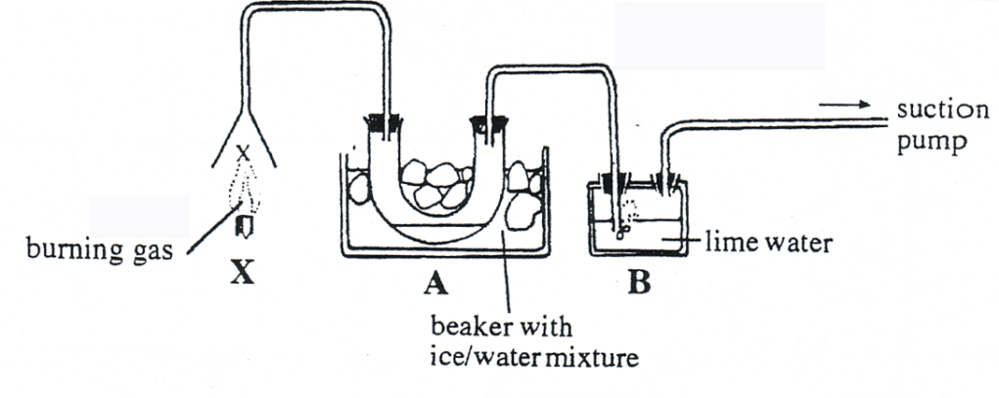

1. Name the 2 products.
2. Name the 2 elements present in element X.
3. What type of substance is liquid X?

3. Crude oil is a mixture of **chemical compounds**. Before the compounds can be used, the crude oil must be separated into fractions.

1. Name the type of compounds found in crude oil.
2. Explain what is meant by a fraction.
3. Describe how crude oil is separated into its fractions.

4. The following questions refer to properties of fractions, collected over the temperature ranges shown:

|  |  |
| --- | --- |
| **Fraction** | **Temperature range (0C)** |
| **1**  **2**  **3**  **4**  **5** | **<40**  **40-75**  **150-240**  **220-250**  **250-350** |

Decide whether each of the following statements about the fractions is **TRUE** or **FALSE.**

1. Fraction 3 is more viscous than fraction 5
2. Fraction 2 changes to a gas more readily than 4
3. Fraction 3 is less flammable than fraction 4.
4. Fraction 5 is thicker than fraction 3.
5. Fraction 1 has a higher boiling point than fraction 5.
6. Fraction 2 burns more easily than fraction 5

5. Some oil was fractionally distilled in a laboratory fume cupboard and the fractions obtained were:

|  |  |
| --- | --- |
| **Fraction** | **Temperature range (0C)** |
| **A**  **B**  **C**  **D**  **E** | **<40**  **40-75**  **150-240**  **220-250**  **250-350** |

(a) What fraction do you think would: (i) have the biggest molecules

(ii) be the most flammable (iii) is most viscous?

(b) How do the size of molecules in a fuel affect (i) flammability?

(ii) viscosity?

6. What elements do hydrocarbons consist of?

7.

1. Write the general formula for the alkenes.

(b) Give the molecular formula for each of the following

(i) butene (ii)methene (iii) octane

(c) Draw the full structural formula for the above compounds

(d) Are alkenes saturated or unsaturated compounds? Explain your answer

8.

1. Write the general formula for the alkanes.

(b) Give the molecular formula for each of the following

(i) ethane (ii)butane (iii) hexane

1. Draw the full structural formula for the above compounds.

9. (a) Name the two products formed from the fermentation of glucose.

(b) Zymase is the enzyme used for fermentation. Where is it found?

(c) How is the alcohol, ethanol, separated from the fermentation mixture?

(d) Why is this method suitable for separating alcohol from water?

(e) Explain why the maximum percentage of alcohol obtained by fermentation is never more than about 15%.

(f) What method is used to increase the % of alcohol in high strength alcoholic drinks?

10. Name three plants and their uses in everyday life

11. Give the name of the reagents that you would use to test for:

(a) Starch

(b) Glucose

12. Glucose is a carbohydrate. What three elements make a carbohydrate compound?