Practical Electronics

Contents
Page number | Topic
2 - 7 | Section 1 – Circuit Theory
8 - 11 | Section 2 – Circuit Simulation and Design
12 - 15 | Section 3 – Circuit Construction



In the next few pages there will be tables with knowledge that must be learned before the National 5 Electronics exam. In the 1st box put a or to show your understanding. You can use the 2nd box to check your understanding at a later date.
Using this sheet will help you become more prepared for your final exam.

Use the extra space sections to include any additional information that you find when doing past paper questions/reading your notes etc…

Section 1 – Circuit Theory
In any calculation you will need to use the correct values. Sometimes a quantity is given with a prefix, for example a current of 20 mA. The prefix here is the symbol m. This means that the current is not 20 A but instead 20 x 10⁻³ A. If you do not change the prefix into a ‘x 10’ then you will not be awarded full marks in each question you do this in.
Prefix (symbol) | power of 10 ( x 10 to )
Mega (M) | x 10⁶
Kilo (K) | x 10³
milli (m) | x 10⁻³
micro (µ) | x 10-⁶
nano (n) | x 10⁻⁹
pico (p) | x 10⁻¹²
The prefixes are;

Current is defined as the number of coulombs of charge per second.
Voltage is defined as the energy given to each coulomb of charge.
Resistance is a measure of the opposition to current in a circuit. If the resistance increases in a circuit the current will decrease. If the resistance decreases the current will increase.
Ohm’s law is simply the equation; V = I R where V = voltage (V), I = current (A) and R = resistance (ohms, Ω).
Voltage is measured using a voltmeter. The circuit symbol for a voltmeter is
V
V
V
V
V
A voltmeter must be connected across a component as shown.

The voltage is always across a component
and never flows through a component.

Current is measured using an ammeter. The circuit symbol for an ammeter is
A

A

A
It must be connected in series with a component as shown.
The current always flows through a component
and never across a component.
Resistance is measured using an ohmmeter. The circuit symbol for an ohmmeter is The resistance is measured by
Ω

Ω
connecting an ohmmeter as shown.

The following symbols represent components that are used in electrical circuits:
Fuse –

Battery –

Cell –

Resistor –

Switch –

Lamp –

Variable resistor –

resistor
a.c. supply –
–

There are two types of circuit called series and parallel. There are rules which must be used for each type of circuit.
 | Current | Voltage
Series circuit | same everywhere | split across components
Parallel circuit | split through branches | same in each branch

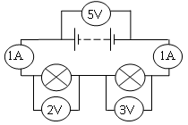
In a series circuit the current is the same size
at any point in the circuit.
Current same

The voltage across the battery is
split across each of the components in
the circuit.
Voltage split

In a parallel circuit the current from the
battery is split through each branch.
Current split
The voltage across each branch is the
same as the voltage across the battery.
Voltage same

To calculate the resistance in a series circuit the equation R_{T} = R₁ + R₂ + … is used.
3Ω
8Ω
10Ω
1A
1A
For example; RT = 10 + 8 = 18 Ω
To calculate resistance in a parallel circuit the equation $\frac{1}{R_{T}}=\frac{1}{R_{1}}+\frac{1}{R_{2}}+…$is used.
An alternative method is to use M.A.D (Multiply. Add. Divide.)
For example; M.A.D. $\frac{10 x 8}{10+8}$ = $\frac{80}{18}$ = 4.4Ω
If both resistors are the same value the total resistance is half. i.e. 10 Ω and 10 Ω in parallel = 5 Ω. The M.A.D. method only works if there are two resistors in parallel. If there are three resistors in parallel M.A.D. must be done twice or the equation $\frac{1}{R_{T}}=\frac{1}{R_{1}}+\frac{1}{R_{2}}+…$ used.
These types of circuits are called voltage dividers. The supply voltage is shared (divided) between the two resistors. There are two ways these questions are solved depending on different conditions.
1 – The supply voltage IS NOT known but V₁ or V₂ is known. Use the equation:
$$\frac{V_{1}}{V_{2}}=\frac{R_{1}}{R_{2}}$$
2 – The supply voltage IS known.
$$V_{2}=\left(\frac{R_{2}}{R_{1}+R_{2}}\right)V_{s}$$
12 V

10 Ω
50 Ω
V₁
V₂

Power is defined as the energy transferred per second.
Power has the symbol P and the units Watts (W)
There are three power equations involving current, voltage and resistance. The best advice here is to look at the information given in the question and select the equation that allows you to find the power. The equations are:
P = I V P = $\frac{V^{2}}{R}$ P = I² R
If current and voltage If voltage and resistance If current and resistance
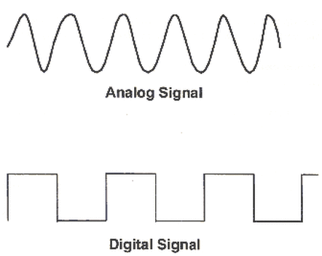
An analogue signal has a range of values from a maximum value to a minimum value
Analogue signal
A digital signal only has two states or two values. These states are called on/off or high/low or 1/0

Using either an analogue or digital signal there are three things that can be determined. The peak voltage, the period of the wave and the frequency of the wave.
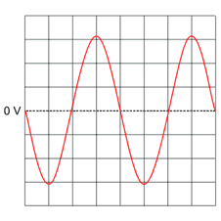
The peak voltage is the voltage at the top of the wave. It is determined by counting the number of boxes from the centre of the wave and multiplying this by the y-gain setting. Remember y-gain is like y-axis (up and down).
Example:
Determine the peak voltage if the y-gain setting is 2 V/div.
Solution:
3 boxes from centre of wave to peak so,
3 x 2 = 6 Volts

The period of the signal is the time taken for one whole wave. It is determined by counting the number of boxes for one whole wave and multiplying by the timebase setting.
Example:
Determine the period of the wave if the timebase is 5 ms/div.
Solution:
4 boxes for one wave so,
4 x (5 x 10⁻³) = 20 x 10⁻³ s

The frequency of the signal is the number of waves in one second. This is a calculation that is done using the equation;

$$f=\frac{1}{T}$$
where f = frequency measured in Hz
and T = period measured in s
Example:
The period of the wave is 20 ms. Calculate the frequency.
Solution:
f = ? $f=\frac{1}{T}$T = 20 x 10⁻³ $f=\frac{1}{{20 x 10}^{-3}}$
f = 50 Hz

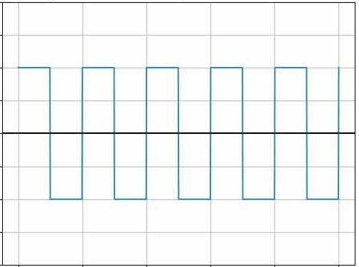
The peak voltage, period of a wave and the frequency of a wave can all be determined from a digital signal in exactly the same way as mentioned above. From this signal there would be two boxes from the centre of the wave to the peak. Also there would be two boxes for one complete wave.

A capacitor is used to store charge. If the capacitance of the capacitor is greater then the capacitor will store more charge. A capacitor with greater capacitance will decrease the flash rate of an LED. The flash rate can be increased by decreasing the capacitance of the capacitor.
Another way to change the flash rate is to change the resistance in the circuit. A resistor of greater resistance will decrease the flash rate and a resistor of smaller resistance will increase the flash rate.
When a current flows in a conductor (a wire) then a magnetic field is produced around the wire. The greater the current the greater the strength of the magnetic field.
The magnetic field can be made even stronger by coiling (wrapping around) the wire around a conductor.
A device which uses and electrical current to produce a magnetic field is called an electromechanical device.
Extra space for additional information

Section 2 – Circuit Simulation and Design
Simulations are used in circuit design for many reasons such as;
- To see if the circuit works
- To improve the circuit design
- Can be changed easily to try different combinations of components
- Can test smaller sub-systems (parts)
Every electronic system has three main parts: Input, process and output.
Logic gates are used to allow an input device to affect an output device. They are digital process devices (only have two states)
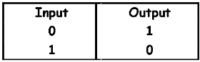
NOT gate – The output is NOT the same as the input.

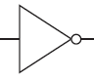
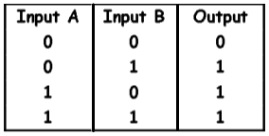
OR gate – The output is a 1 if input A OR input B are a 1.

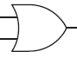
AND gate – The output is a 1 only if Input A AND input B are a 1.
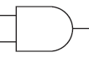

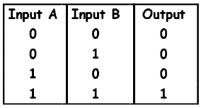
NOR gate – This gate works in the opposite way from an OR gate

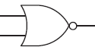
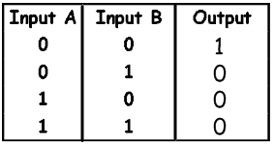
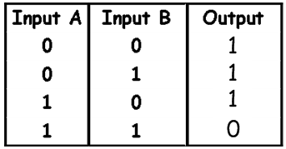
NAND gate – This gate works in the opposite way from an AND gate.

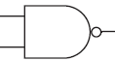
XOR gate – This gate will give an output of 1 ONLY if input A or input B are a 1 and not if both inputs are a 1. It is an exclusive OR gate.

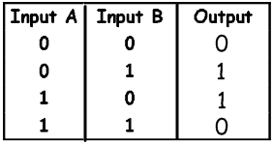
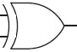
There may be faults with a circuit which you must identify. The three most common faults are;
- A supply voltage which is too high or too low.
- Incorrect resistor values which again are too high or too low.
- Having components connected the wrong way (a diode or LED which is not facing the negative terminal). This is called component orientation and the word orientation must be used.

Before constructing a circuit you should compile a pre-power up checklist to make sure the circuit will work properly. This will include;
- checking the components are connected the correct way (correct orientation)
- Checking the supply voltage is appropriate.
- Checking the resistor values are appropriate.
Half-adder circuit
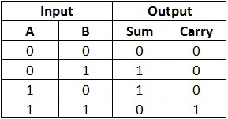
This circuit is used to add up numbers using logic gates. The XOR gate and AND gate are used.

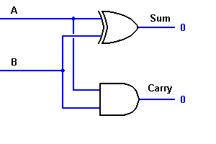
The inputs A and B can only be a 1 or 0. This means there are 4 possible outputs as shown in the truth table.

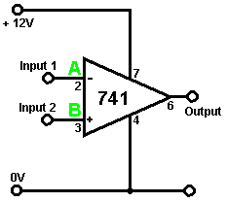
741 comparator
This component is an op-amp which is used to compare the voltage of two signals. When it measures the voltage of each signal it can then be used to show which signal has the greatest voltage.

A transistor is used as an electronic switch to conduct electrical current if the voltage across the transistor is high enough. There are two types;
collector
base
emitter

MOSFET transistor – switches on at 2 V
bipolar transistor – switches on at 0.7 V

The base is always connected to the input device.
The collector is always connected to the output device.
The emitter is always connected to the zero volt rail.
You may be asked to describe how a circuit like this works. Split your answer into 4 parts:
- Say what happens to the resistance of the LDR if light level decreases – LURD.
- If the resistance increases the voltage across the LDR will increase and vice versa.
- If the voltage is large enough the transistor will switch on.
- Current will pass through the LED and
it will light.
You can get different versions of the circuit above. The best advice is to mention what is happening at each stage by starting with the LDR or thermistor, the voltage across the base and emitter and then what happens to the output device.

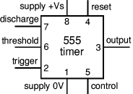
A 555 timer is used to send a regular signal to an output device. It could be used to make an LED light flash on and off. The symbol shows the location of each pin.

1. Connected to 0 V rail.
2. Connected to the capacitor.
3. Is connected to the output device (LED).
4. Connected to the positive voltage rail.
5. Not connected to anything.
6. Connected to the capacitor.
7. Connected back into the input part (usually a resistor).
8. Connected to the positive voltage rail.
Extra space for additional information

Section 3 – Circuit Construction
Resistors have different values which can range from a few ohms (Ω) to Millions of ohms (Ω). Prefixes kilo (K) and Mega (M) are often used with resistors.
BS notation or R notation is used to identify the resistance of a resistor.
If the resistance is less than 1 thousand ohms it is written as;
270 Ω would be 270R. 560 Ω would be 560R.
If the resistance is between 1 thousand and 1 million ohms it is written as;
2700 Ω would be 2k7. 56000 Ω would be 56k.
If the resistance greater than 1 million ohms it is written as;
3000000 Ω would be 3M. 5600000 Ω would be 5M6
The resistance of a resistor is found using a colour code (although the image will be in black and white!). Looking at the colours starting from the left the first and second colour are the first and second value of the resistance and the third colour is a multiplier. The fourth colour is the tolerance of the resistance.
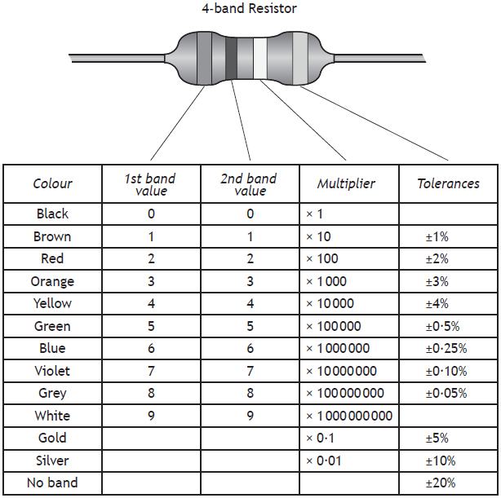

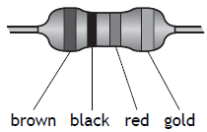
This resistance would be;
You will be given this table in any exam.

10 x 100 = 1000 Ω with a tolerance ± 5%
R = 1000 Ω ± 5%

The tolerance is a percentage and is used to calculate the maximum and minimum resistance value allowed for that resistor. The first step is to find out what the tolerance is using the equation: $\frac{value}{100} x tollerance$
i.e. Calculate a tolerance of 10% of a 200 Ω resistor: $\frac{200}{100}$x 10 = 20 Ω.

To calculate the maximum resistance of a resistor you would ADD the tolerance to the value. So: 200 + 20 = 220 Ω.
To calculate the minimum resistance of a resistor you would SUBTRACT the tolerance from the value. So: 200 - 20 = 180 Ω.

Input devices with their symbols which should be used when drawing them:
Have NO positive or negative side. Usually have a low capacitance value.

Non-Electrolytic Capacitor –

Have a positive and negative side. Usually have higher capacitance values.

+
Electrolytic Capacitor –

Thermistor – As temperature increases the resistance
(Temperature sensor) decreases.
Temperature Up Resistance Down - TURD

LDR – As light level increases the resistance
(Light dependent reisistor) decreases.
Light Up Resistance Down - LURD

Output devices with their symbols which should be used when drawing them:
M
Motor – Electrical energy to kinetic energy. Energy
wasted as heat and sound.

Loudspeaker – Electrical energy to sound energy. An
analogue device.

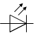
LED– Electrical energy to light energy. Very little
(Light emitting diode) energy wasted as heat so LEDs are much
more efficient than lamps.

Relay – Used to allow a circuit with low current
(safe) to control a circuit with high current
(unsafe). When a current passes through
the coil a magnetic field is produced. This
closes the relay switch allowing the second
circuit.
to operate.

Buzzer – Electrical energy to sound energy. A digital
device.

A diode – It is used to allow electrical current to flow in one direction. It
will only conduct electrical current if it faces/points toward
the negative terminal of the battery.
A continuity tester can be used to test for good connections. It is a lamp or LED connected to a power supply with two wires. To test for good connections the continuity tester would be;
- connected to both ends of the wire or component that is being tested.
- The LED would light.
A logic probe would work in the same way to a continuity tester but is used to test if the logic state is a 1 or a 0.
When soldering there are safety measures which must be taken;
- wear eye protection
- good ventilation
- avoid breathing fumes
When connecting two boards together spiral wrapping is used to protect the wires. This is plastic and spirals around the wires which are used.
When connecting two boards together it is important to identify the correct wiring between the boards. This can be done by;
- colour coding the wires
- numbering the wires
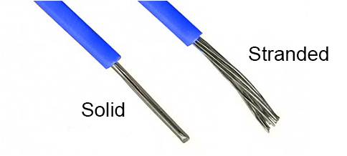
Multi-strand cables are used as they are flexible and are not easily broken. If a single strand cable was used it may be broken more easily.
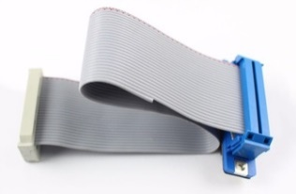
Ribbon cables are used for connecting electronic components which have lots of wires. This means they can all be connected at once and do not need to be connected individually.
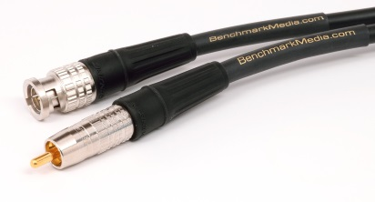
Co-axial cables are used to send radio frequency signals. These are used when connecting sky TV.

Fibre optic cables are used to send light signals. These are used for Virgin TV and usually use laser light to send a signal.


Extra space for additional information

